Catalogue des pièces 2018

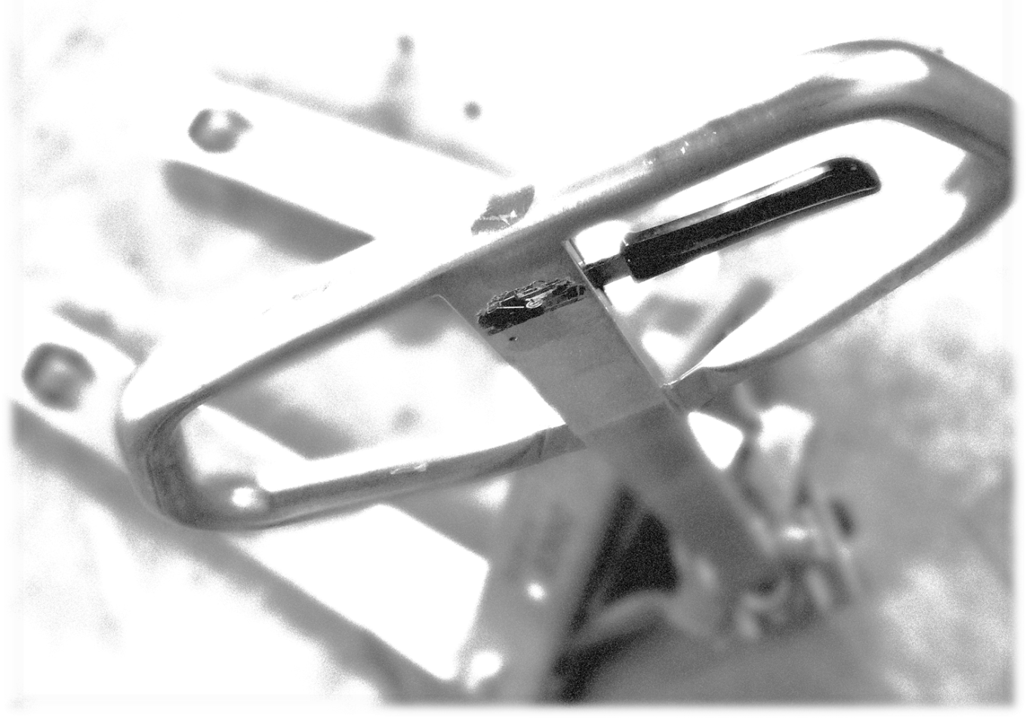

Table des matières
Pompes hydrauliques 5
Big Jack – TLC 6
Châssis 6
Unité hydraulique 7
Big Jack – WB 8
Châssis 8
Unité hydraulique 9
Poignée 10
Big Jack – BF-I 11
Châssis 11
Unité hydraulique 12
Unité hydraulique avec système de freins 13
Unité hydraulique « quick pompe » 14
Big Jack – BFWL (4-way) 15
Châssis 15
Unité hydraulique 16
BT – BTL2000 17
Châssis 17
Unité hydraulique 18
Poignée 19
BT – LHM230 Série 20
Châssis 20
Unité hydraulique & Poignée 21
Unité hydraulique « quick pompe 23
PST 25
C-55 / ELP-55 / ALTRA 26
Unité hydraulique 26
Châssis 27
Poignée 28
Dakota – SYBC 29
Unité hydraulique & Poignée 29
Châssis 30
H-55 31
Unité hydraulique – Type A 31
Unité hydraulique – Type Y 32
Unité hydraulique – Quick pompe 33
Châssis 34
Poignée 35
Lift-Rite – L50 36
Unité hydraulique & Poignée 36
Châssis 37
Option roue tandem 38
Option système de freins 38
Lift-Rite – LR2055 39
Unité hydraulique 39
Châssis 40
Option roue tandem 41
Option système de freins 41
Lift-Rite – Titan LCR55 & LCS55 42
Unité hydraulique & Poignée 42
Châssis 43
Châssis 44
Lift-Rite – Ergo – RG-30E & RG-30M 45
Châssis 45
Plaque d’appui 46
Lift-Rite – Ergo – RG-30E 47
Unité hydraulique & Poignée 47
Composantes électriques 49
Lift-Rite – Ergo – RG-30M 50
Unité hydraulique & Poignée 50
Mahaffy – Wrangler 52
Unité hydraulique 52
Châssis 53
Mobile – ML50 et ML55 54
Châssis 54
Mobile – ML50 55
Unité hydraulique 55
Mobile – ML55 56
Unité hydraulique 56
Mobile – BF II (Eco) 57
Châssis 57
Unité hydraulique 58
Toyota – HPT28U 59
Châssis 59
Unité hydraulique et poignée 60
Toyota – HPT-SS (inox) 61
Châssis 61
Unité hydraulique et poignée 62

Pompes hydrauliques
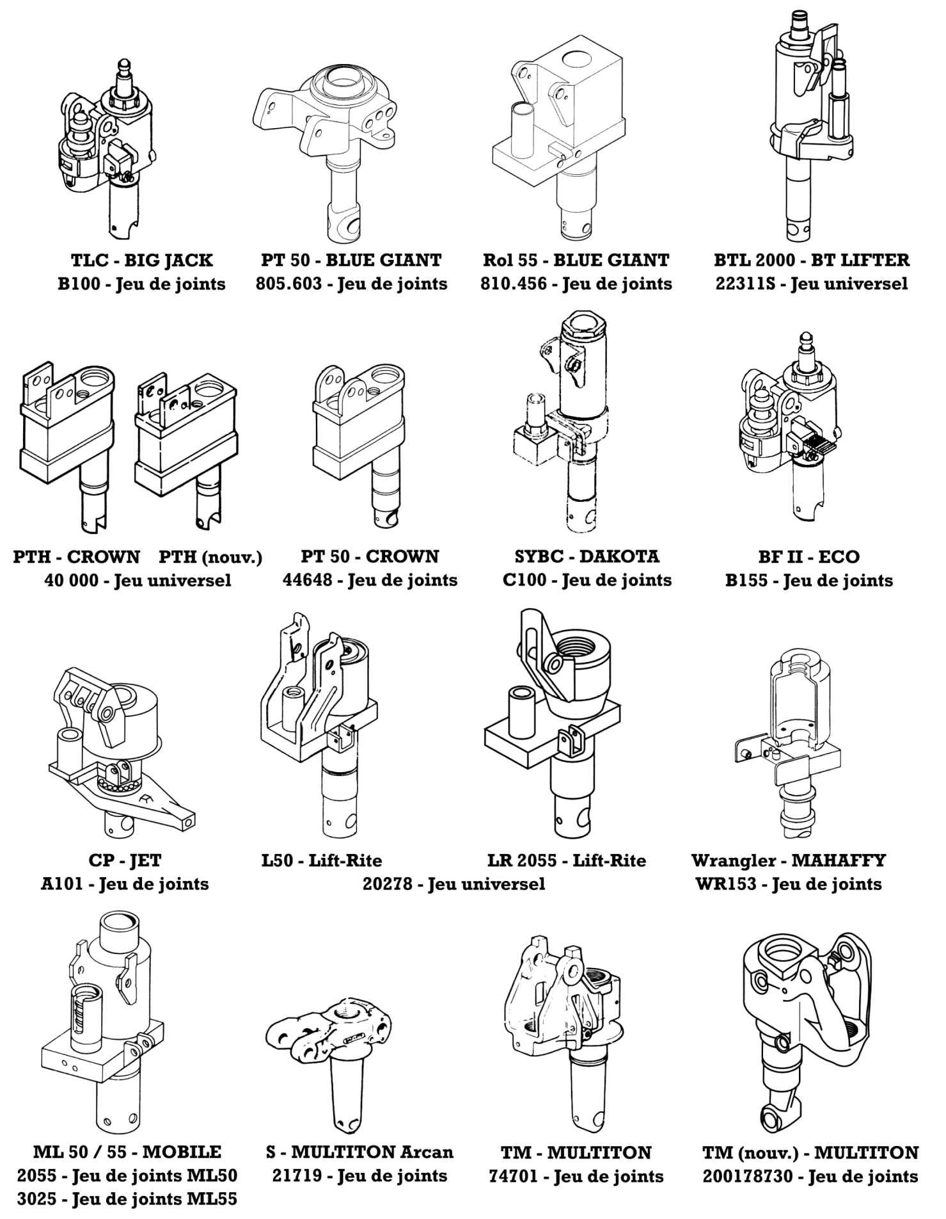

Big Jack – TLC

Châssis
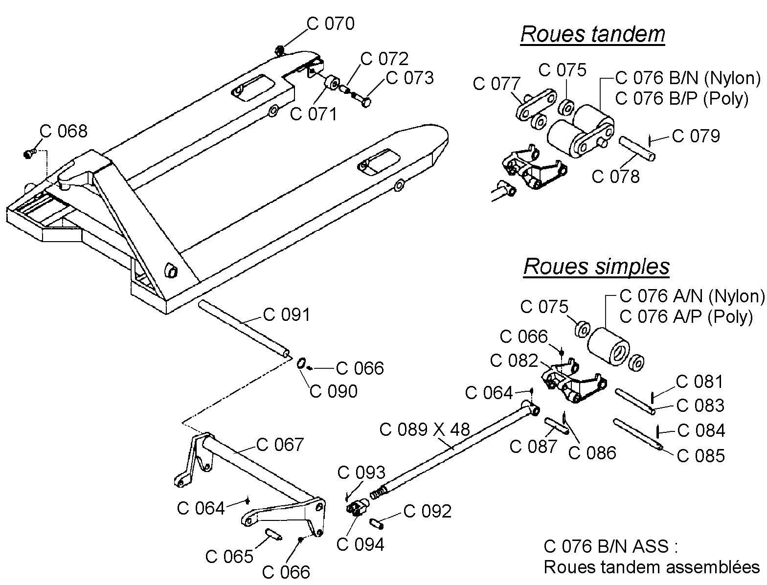

Big Jack – TLC

Unité hydraulique
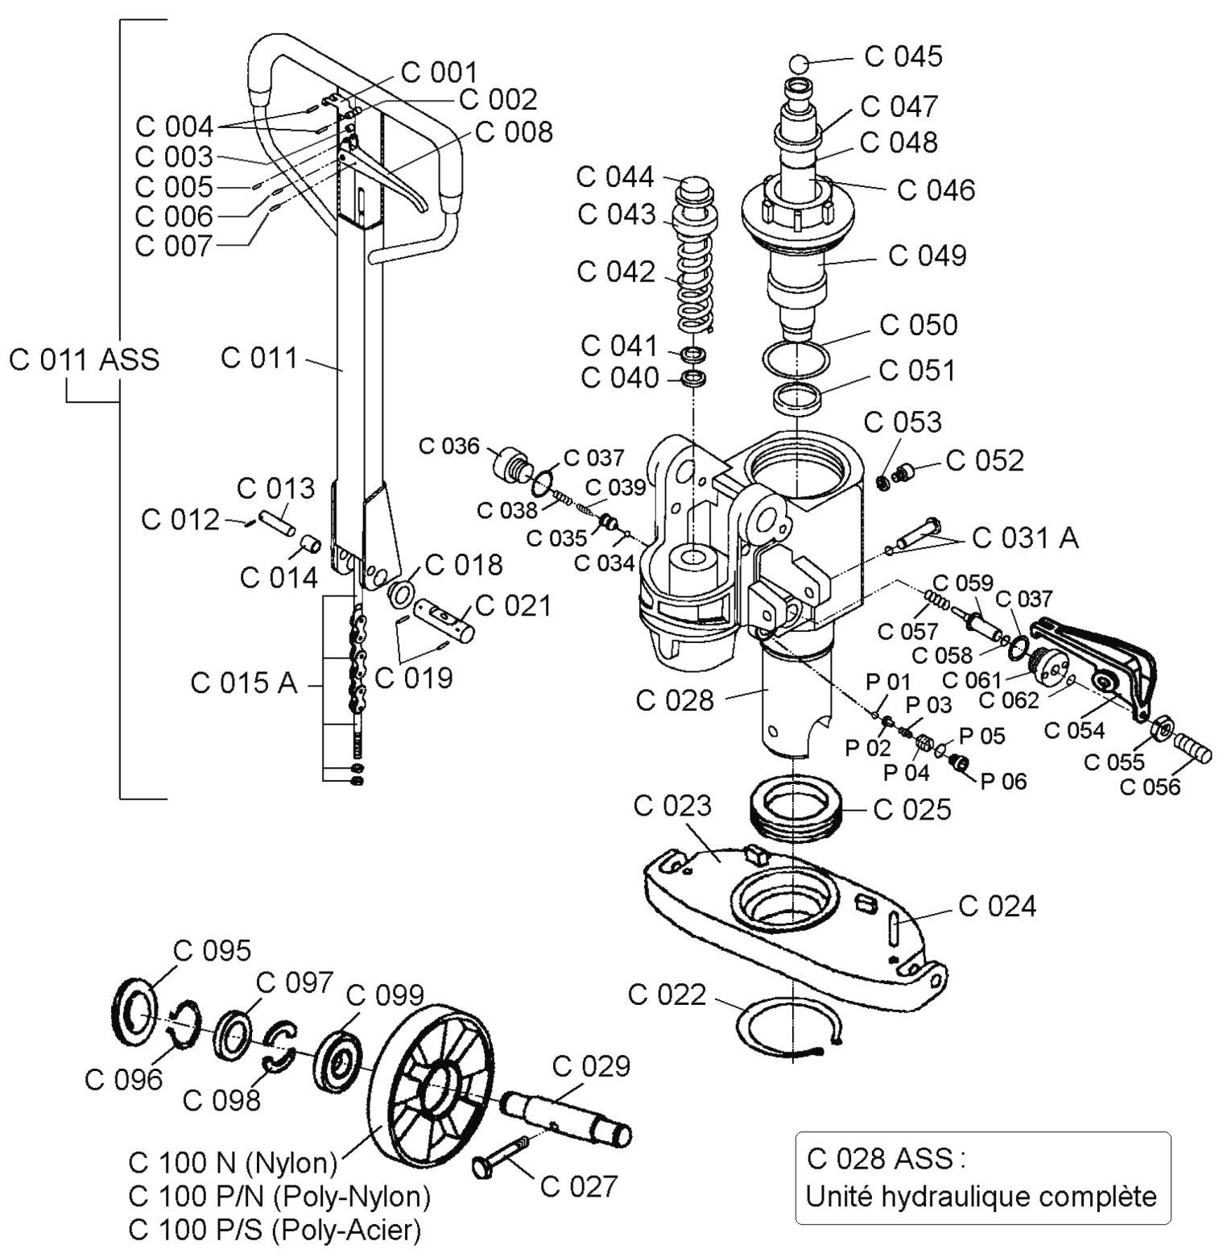

Big Jack – WB (10 000 lb)

Châssis

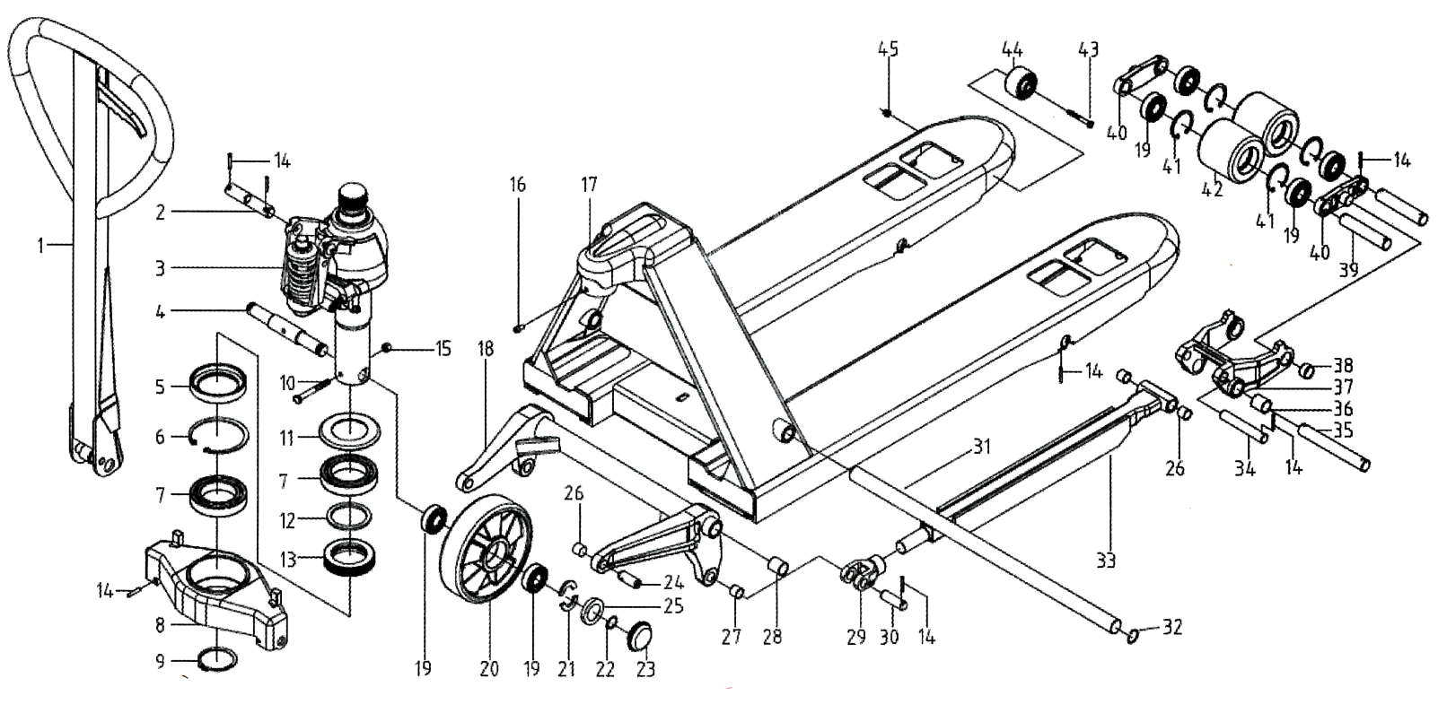

1 | WB.3B-00 |  | 16 | GB/T70.1 |  | 31 | AF-02
2 | WA-01 |  | 17 | WB.4-00 |  | 32 | GB898.1-86
3 | WB.2-00 |  | 18 | WB.6-00 |  | 33 | WB.5.1-00
4 | WB.9-01 |  | 19 | GB/T276-94 |  | 34 | DB.3.3-01
5 | WB-2 |  | 20 | Roue |  | 35 | WB-05
6 | GB893.1-86 |  | 21 | AF-05 |  | 36 | CSB-5 (20x23x25)
7 | GB/T276-94 |  | 22 | GB894.1-86 |  | 37 | WB.5-01
8 | WB-03 |  | 23 | DF-10 |  | 38 | CSB-F (20x23x12)
9 | GB-894.1-86 |  | 24 | WA-02 |  | 39 | WB.8-02
10 | GB5782 |  | 25 | AF-06 |  | 40 | Af.7-04
11 | WB-01 |  | 26 | CSB-F (16x18x15) |  | 41 | GB893.1-86
12 | WB-06 |  | 27 | CSB-F (16x18x20) |  | 42 | WB.8-01
13 | GB301-95 |  | 28 | CSB-F (25x30) |  | 43 | GB5782
14 | GB879.01 |  | 29 | BF12 |  | 44 | WEC-05
15 | GB889.1-86 |  | 30 | DF-01 |  | 45 | GB889.1

Big Jack – WB (10 000 lb)

Unité hydraulique

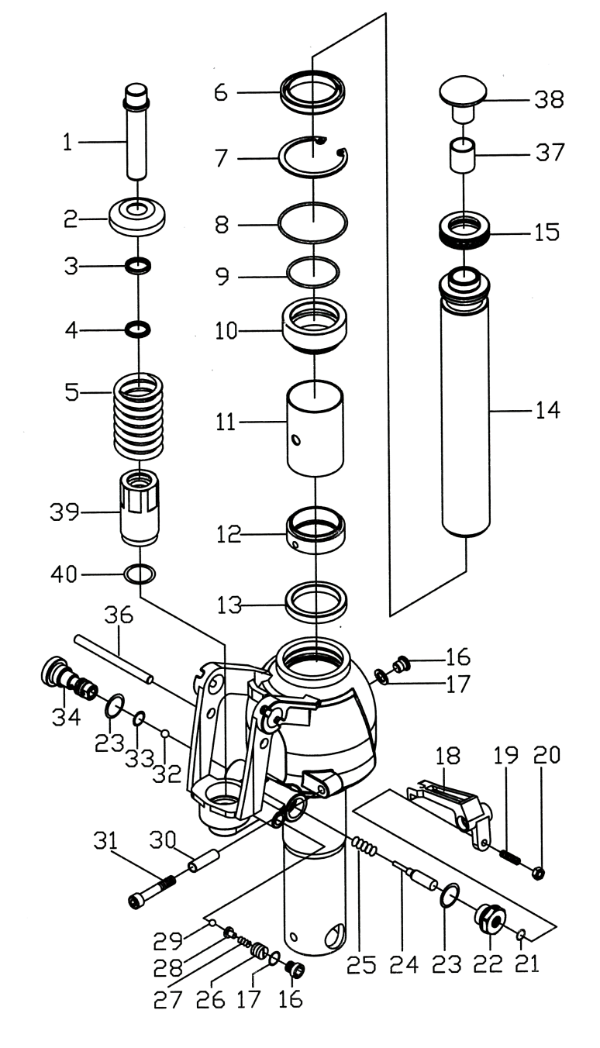
1 | BF.2-1a
2 | KC.2-05
3 | DH18
4 | UHS18
5 | BF.2-05
6 | Rondelle (54x57)
7 | GB893.1-86
8 | GB3452.1-82 (58x3.55)
9 | GB3452.1-82 (45x3.55)
10 | WB.2-01
11 | WB.2-04
12 | WB.2-05
13 | UHS35
14 | WB.2-03
15 | GB301-1995
16 | CN.2-17
17 | JB982-77
18 | WA.2-06
19 | GB71-1985
20 | GB/T6170-2000
21 | GB3452.1-82
22 | WA.2-05
23 | JB982-77
24 | EF.2-03
25 | SYBC.2-06
26 | CN.2-29
27 | CN.2-28
28 | CN.2-26
29 | GB308-77 (5)
30 | WA.2-07
31 | GB/T70.1-2000
32 | GB308-77 (7)
33 | GB3452.1-82 (10x2.65)
34 | KO3-00
35 | WB.2.1-00
36 | AM-19
37 | Bushing (20x23x25)
38 | WB.2-02
39 | AM.2-04B
40 | GB3452.1-82 (2.65x23.6)

Big Jack – WB (10 000 lb)

Poignée

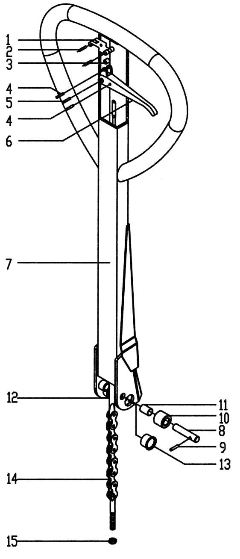

1 | DF.1-01a
2 | GB879-86 (4x30)
3 | DF.1-02
4 | GB879-86 (4x20)
5 | GB879-86 (6x30)
6 | DF.1-03
7 | WB.3.1-00
8 | DF.2-04
9 | GB879-86 (3x20)
10 | CN.2-13
11 | CSB10
12 | DF.1.2-00
13 | SF-1
14 | Chaîne C-6-9-04A
15 | GB889-86

Big Jack – BF-I

Châssis
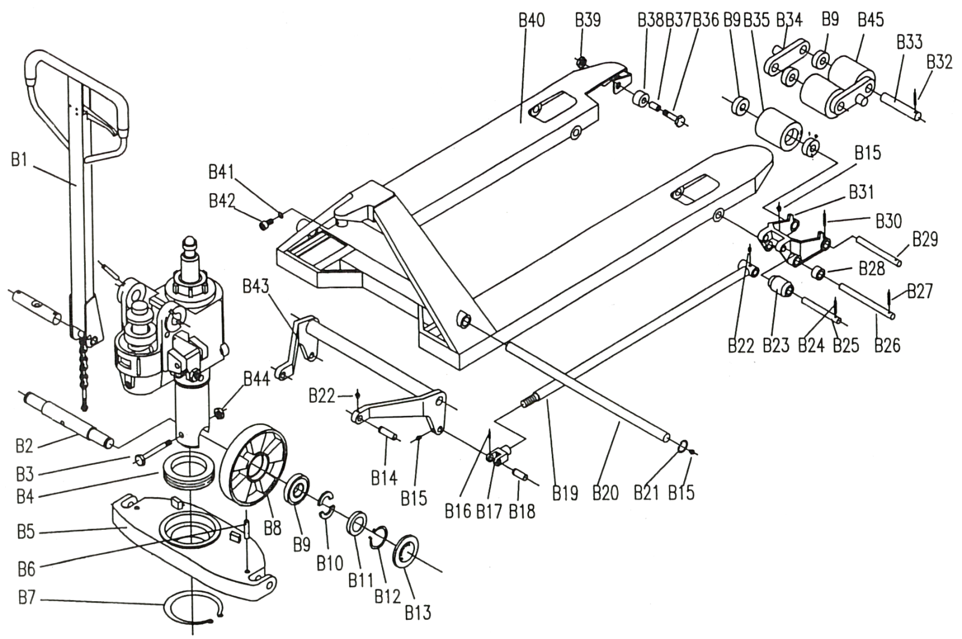

Big Jack – BF-I

Unité hydraulique

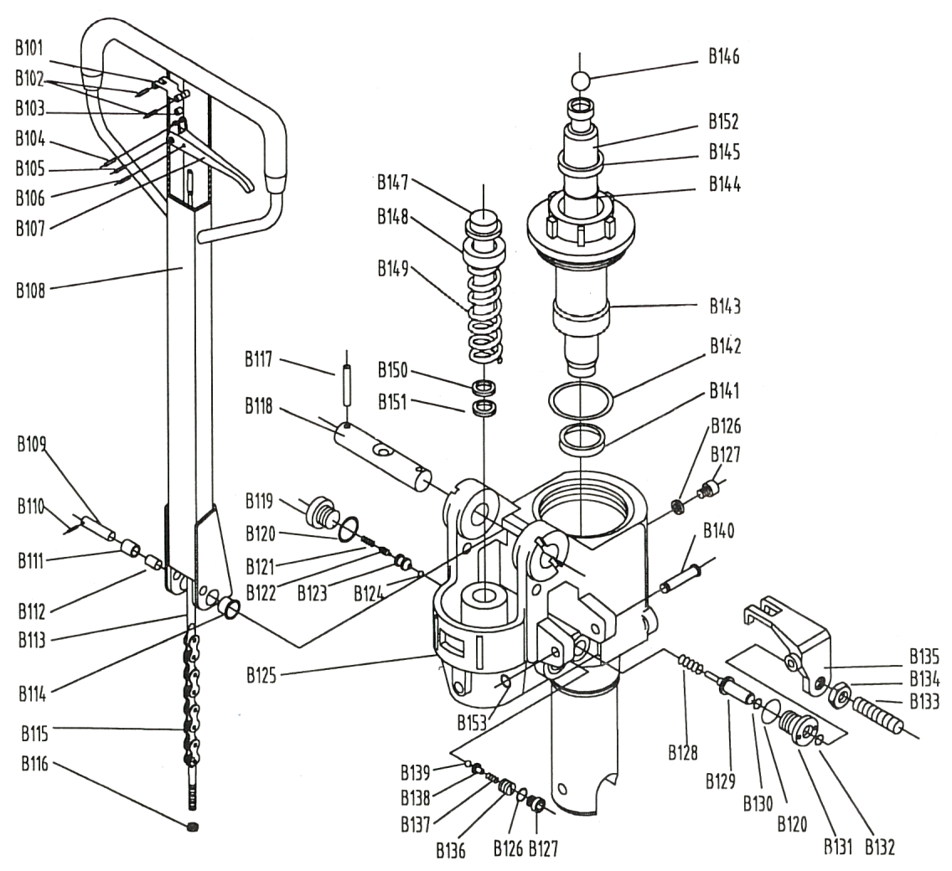

Big Jack – BF-I

Unité hydraulique avec système de freins
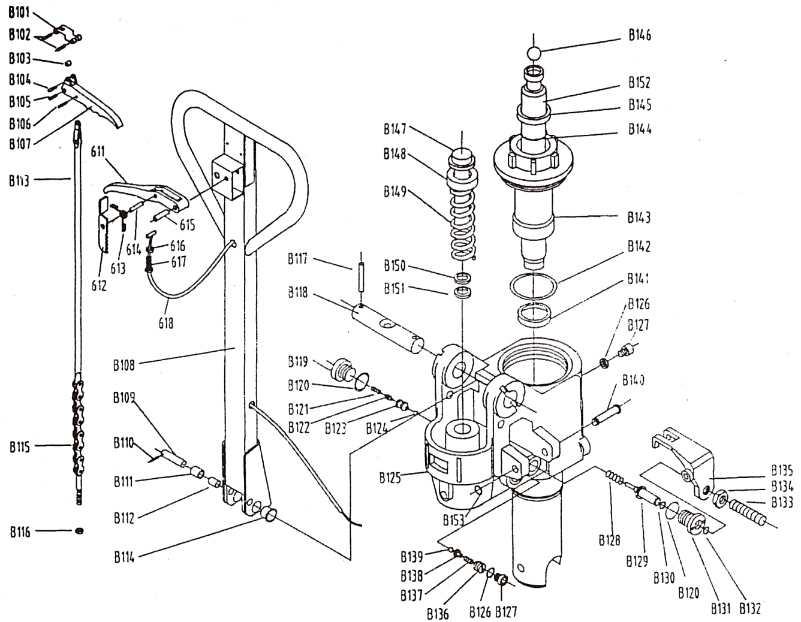

Big Jack – BF-I

Unité hydraulique « quick pompe »
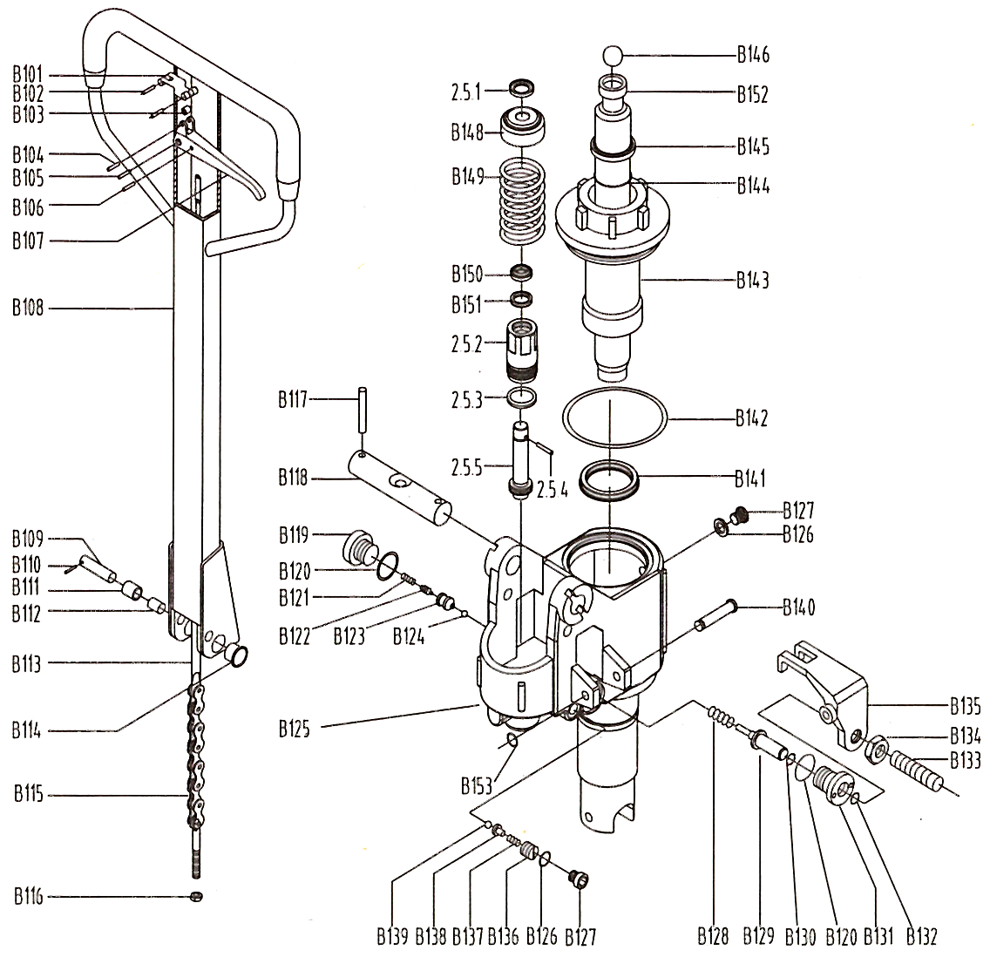

Big Jack – BFWL (4-way)

Châssis

Nouvelle image à venir

Big Jack – BFWL (4-way)

Unité hydraulique

Nouvelle image à venir

BT – BTL2000

Châssis
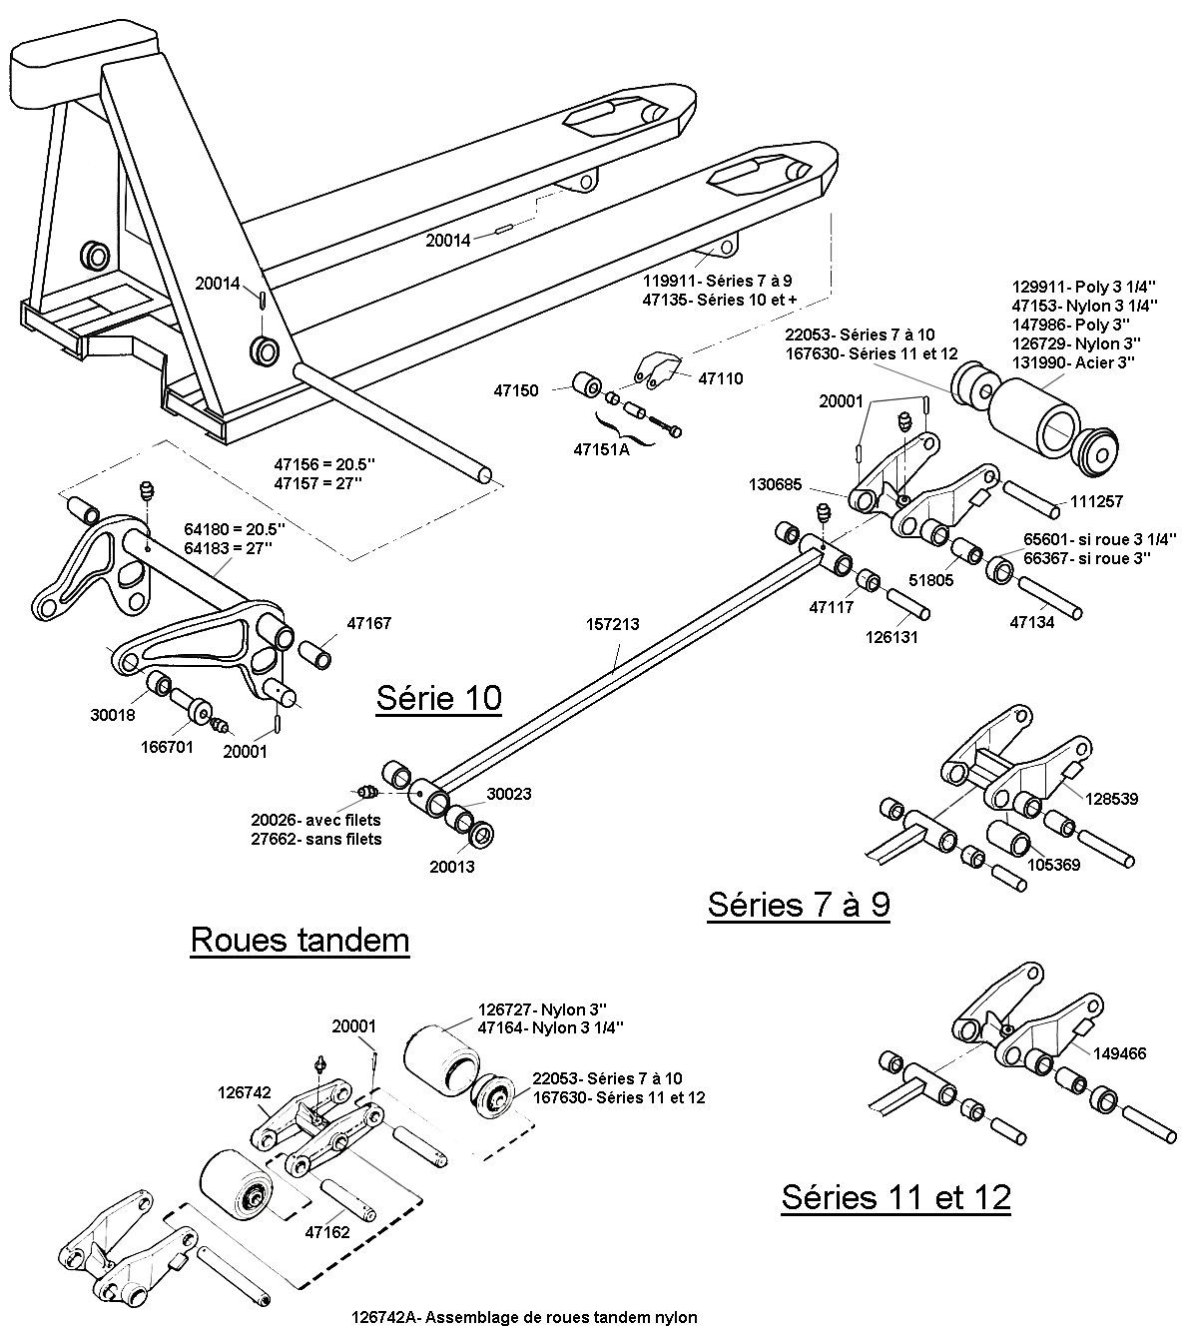

BT – BTL2000

Unité hydraulique
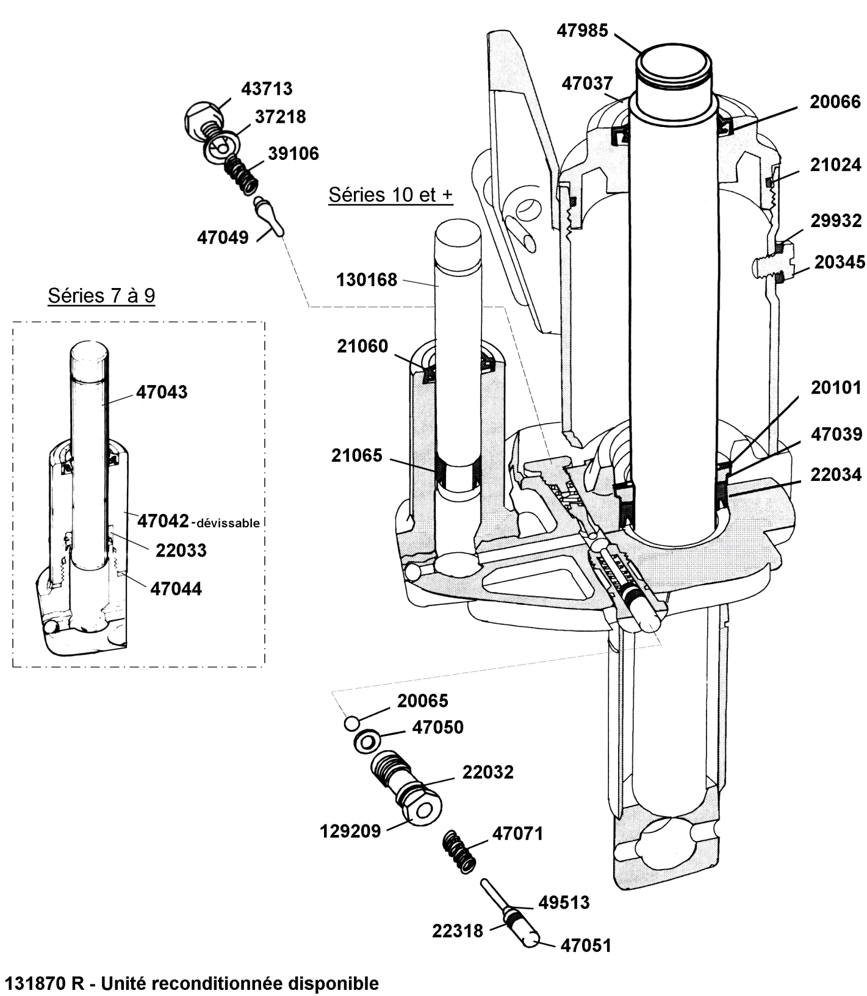

BT – BTL2000

Poignée
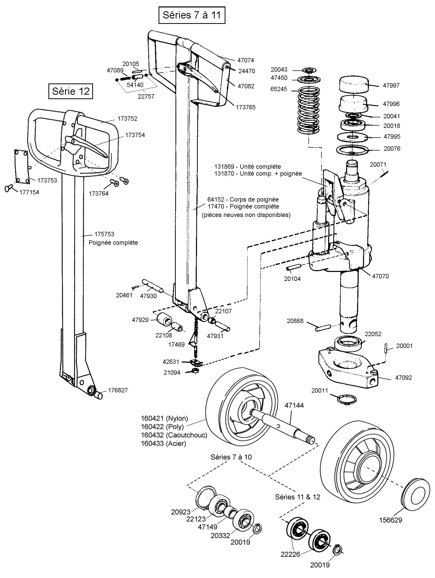

BT – LHM230 Série

Châssis
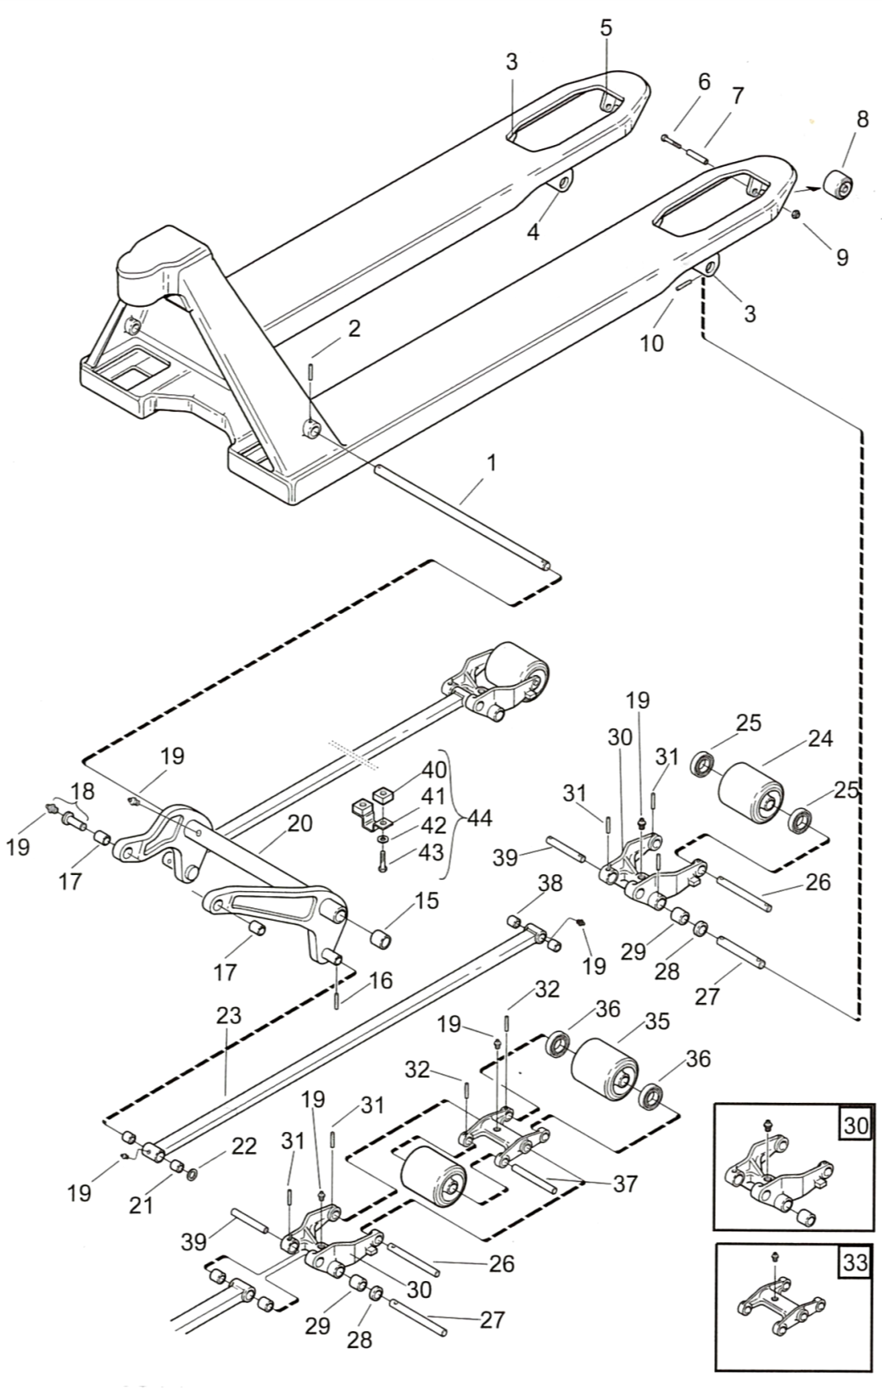 |  | 1 | 47156
 |  |  | 47157 (685 mm)
 |  | 2 | 22128
 |  | 3 | 47135
 |  | 4 | 47136
 |  | 5 | 47110
 |  | 6 | 21385
 |  | 7 | 47151
 |  | 8 | 47150
 |  | 9 | 20433
 |  | 10 | 20014
 |  | 15 | 47167
 |  | 16 | 20001
 |  | 17 | 30018
 |  | 18 | 166701
 |  | 19 | 27662 (roue simple)
 |  |  | 27662 (roue bogie)
 |  | 20 | 64180 (250 mm)
 |  |  | 64183 (685 mm)
 |  | 21 | 30023
 |  | 22 | 20013
 |  | 23 | 109566-080 (800 mm)
 |  |  | 109-566-091 (910 mm)
 |  |  | 109566-100 (1000 mm)
 |  |  | 109566-107 (1070 mm)
 |  |  | 109566-115 (1150 mm)
 |  |  | 113990-152 (1520 mm)
 |  |  | 113990-183 (1830 mm)
 |  |  | 157213 (1220 mm)
 |  | 24 | 167600 (nylon)
 |  |  | 167609 (poly)
 |  | 25 | 167630
 |  | 26 | 47133
 |  | 27 | 47134
 |  | 28 | 66367
 |  | 29 | 51805
 |  | 30 | 149466
 |  | 31 | 20001
 |  | 32 | 20001
 |  | 33 | 179206
 |  | 35 | 167611
 |  | 36 | 167630
 |  | 37 | 47162
 |  | 38 | 47117
 |  | 39 | 126131
 |  | 40 | 159208
 |  | 41 | 159209
 |  | 42 | 20404
 |  | 43 | 20184
 |  | 44 | 159842

BT – LHM230 Série

Unité hydraulique & Poignée
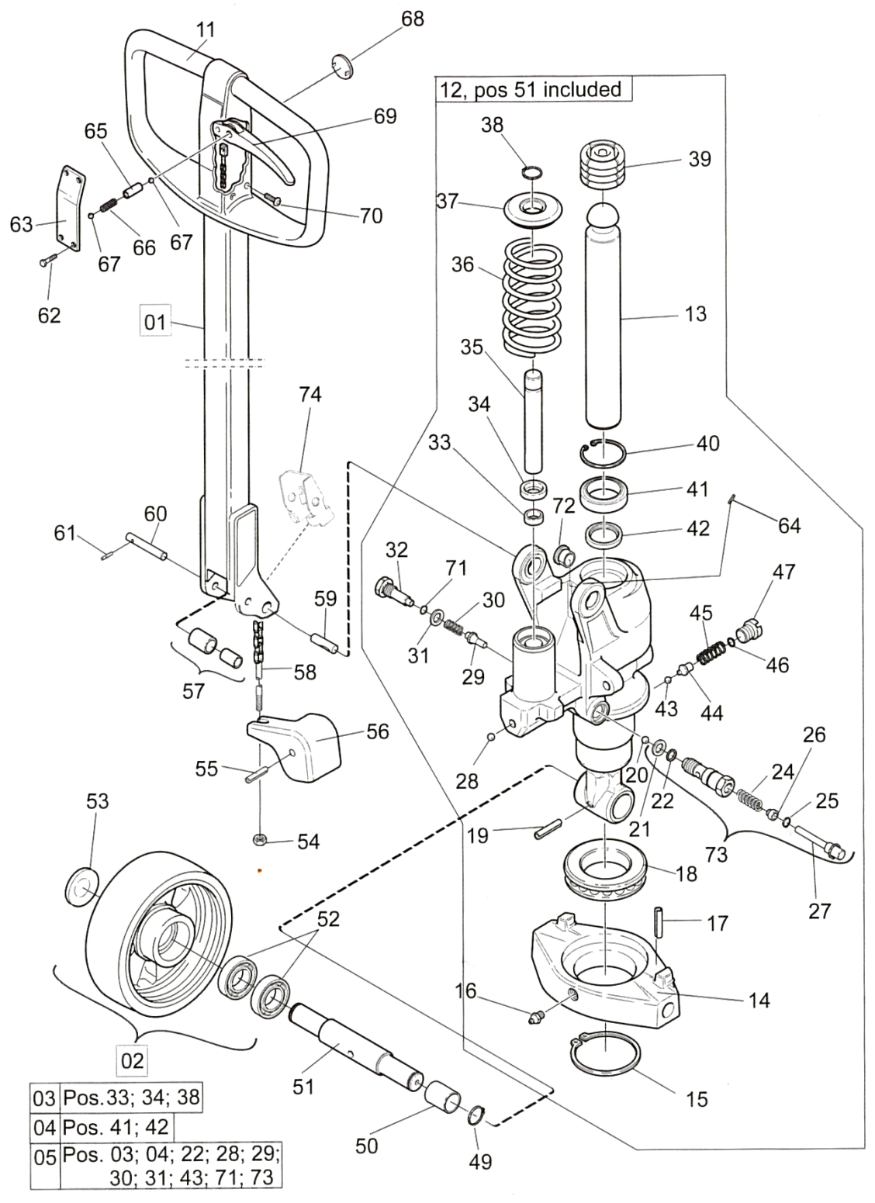

Voir page suivante pour les numéros de pièces

1 | 215131 (Std, U, O, WS, SI) |  | 18 | 213056 |  | 49 | 20019
 | 227091 (P, OP, QP) |  |  | 228275 (WS) |  | 50 | 161637
 | 227160 (X, UX) |  | 19 | 220312 |  | 51 | 220310
2 | 157104 |  | 20 | 20065 |  |  | 227907 (WS)
 | 160421 (nylon) |  | 21 | 215288 |  | 52 | 22226
 | 160422 (poly) |  | 22 | 22032 |  |  | 210062 (WS)
 | 160432 (caoutchouc) |  | 24 | 47071 |  | 53 | 156623
 | 160433 (acier) |  | 25 | 22318 |  | 54 | 21094
 | 161804 (WS; nylon) |  | 26 | 49513 |  | 55 | 220312
 | 161806 (WS; poly) |  | 27 | 47051 |  | 56 | 215128
 | 161807 (WS; caoutchouc) |  | 28 | 20065 |  | 57 | 202755
 | 200965 (powerthane) |  | 29 | 223935 |  | 58 | 215775
 | 208455 (P, OP, QP) |  | 30 | 39106 |  | 59 | 222750
3 | 243926 |  | 31 | 235545 |  |  | 227911 (WS)
4 | 243927 |  | 32 | 221586 |  | 60 | 47930
5 | 243772 |  | 33 | 215866 |  | 61 | 20461
11 | 173752 (Std, U, O, WS, SI) |  | 34 | 21060 |  | 62 | 177154
 | 173759 (X, UX) |  | 35 | 215286 |  | 63 | 173753
12 | 215031(O, UO) |  | 36 | 215156 |  | 64 | 20014
 | 220069 (Std, U, SI) |  | 37 | 215282 |  | 65 | 54140
 | 227083 (P) |  | 38 | 20043 |  | 66 | 218182
 | 227085 (OP) |  | 39 | 215803 |  | 67 | 20065
 | 227294 (U, UX) |  | 40 | 20642 |  | 68 | 173755
 | 227910 (WS) |  | 41 | 20066 |  | 69 | 173754
13 | 215030 |  | 42 | 215867 |  | 70 | 173764
14 | 215092 |  | 43 | 22055 |  | 71 | 24213
15 | 21737 |  | 44 | 221231 |  | 72 | 215913
 | 228129 (WS) |  | 45 | 221227 |  | 73 | 243904
16 | 27662 |  | 46 | 22032
17 | 20001 |  | 47 | 221232 (2300 kg)
 |  |  |  | 223922 (1000 kg)

BT – LHM230 Q Série

Unité hydraulique « quick pompe
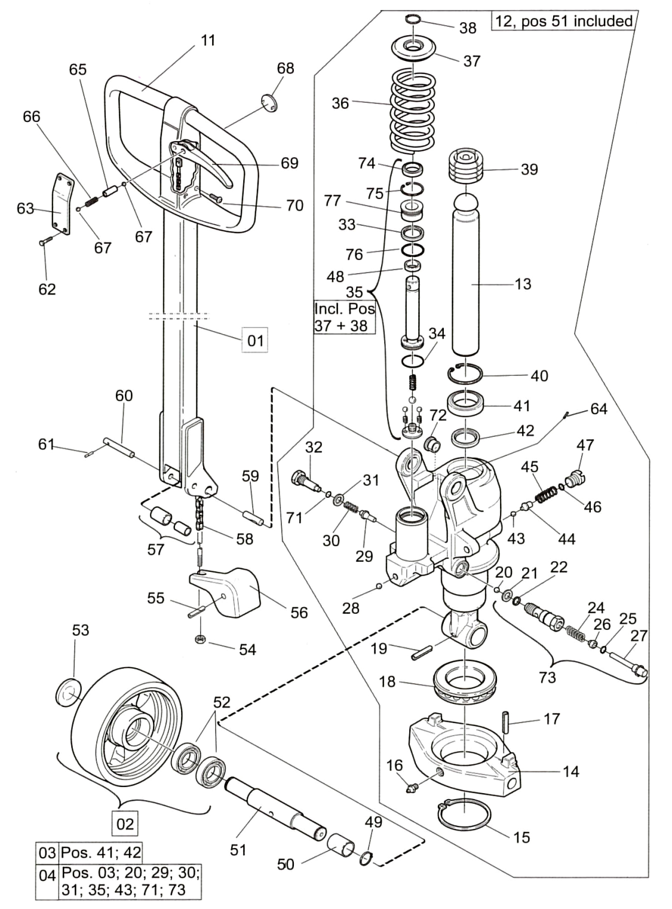

Voir page suivante pour les numéros de pièces

1 | 215131 (Q, UQ, QO, QWS) |  | 21 | 215288 |  | 51 | 220310
 | 227091 (QP) |  | 22 | 22032 |  |  | 227907 (QWS)
 | 227160 (QX, UQX) |  | 24 | 47071 |  | 52 | 210062 (WS)
2 | 157104 (caoutchouc. électr.) |  | 25 | 22318 |  |  | 22226
 | 160421 (nylon) |  | 26 | 49513 |  | 53 | 156623
 | 160422 (poly) |  | 27 | 47051 |  | 54 | 21094
 | 160432 (caoutchouc) |  | 28 | 20065 |  | 55 | 220312
 | 160433 (acier) |  | 29 | 223935 |  | 56 | 215128
 | 161804 (QWS; nylon) |  | 30 | 39106 |  | 57 | 202755
 | 161806 (QWS; poly) |  | 31 | 235545 |  | 58 | 215775
 | 161807 (QWS; caoutchouc) |  | 32 | 221586 |  | 59 | 222750
 | 200965 (powerthane) |  | 33 | 215838 |  |  | 227911 (QWS)
 | 208455 (QP) |  | 34 | 215909 |  | 60 | 47930
3 | 243927 |  | 35 | 243923 |  | 61 | 20461
4 | 243773 |  | 36 | 215156 |  | 62 | 177154
11 | 173752 |  |  | 227090 (QP) |  | 63 | 173753
12 | 215265 (QO) |  | 37 | 215282 |  | 64 | 20014
 | 220161 (Q, UQ) |  | 38 | 20043 |  | 65 | 54140
 | 227087 (QP) |  | 39 | 215803 |  | 66 | 218182
 | 227296 (QX, UQX) |  | 40 | 20642 |  | 67 | 20065
 | 249158 (QWS) |  | 41 | 20066 |  | 68 | 173755
13 | 215030 |  | 42 | 215867 |  | 69 | 173754
14 | 215092 |  | 43 | 22055 |  | 70 | 173764
15 | 21737 |  | 44 | 221231 |  | 71 | 24213
 | 228129 (QWS) |  | 45 | 221227 |  | 72 | 215913
16 | 27662 |  | 46 | 22032 |  | 73 | 243904
17 | 20001 |  | 47 | 221232 (2300 kg) |  | 74 | 215865
18 | 213056 |  |  | 223922 (1000 kg) |  | 75 | 243891
 | 228275 (QWS) |  | 48 | 215866 |  | 76 | 215907
19 | 220312 |  | 49 | 20019 |  | 77 | 211828
20 | 20065 |  | 50 | 161637

BT – LHM230 Série

PST
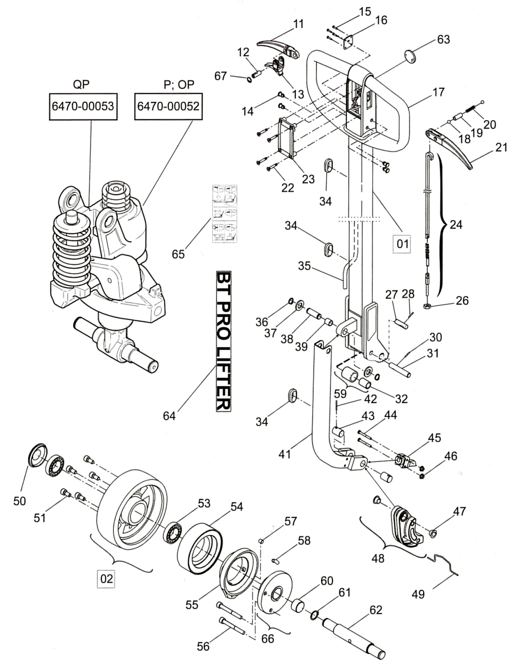 |  | 1 | 227091
 |  | 2 | 208455 (powerthane)
 |  |  | 214747 (powerfriction)
 |  | 11 | 214747
 |  | 12 | 211059
 |  | 13 | 211057
 |  | 14 | 173764
 |  | 15 | 28297
 |  | 16 | 216337
 |  | 17 | 211400
 |  | 18 | 20065
 |  | 19 | 54140
 |  | 20 | 218182
 |  | 21 | 173754
 |  | 22 | 177154
 |  | 23 | 173753
 |  | 24 | 215775
 |  | 26 | 21094
 |  | 27 | 222750
 |  | 28 | 20014
 |  | 30 | 20461
 |  | 31 | 47930
 |  | 32 | 22108
 |  | 34 | 22444
 |  | 35 | 211401
 |  | 36 | 20207
 |  | 37 | 22547
 |  | 38 | 212907
 |  | 39 | 21706
 |  | 41 | 211396
 |  | 42 | 20524
 |  | 43 | 208454
 |  | 44 | 28341
 |  | 45 | 212208
 |  | 46 | 25699
 |  | 47 | 211008
 |  | 48 | 212584
 |  | 49 | 211061
 |  | 50 | 156623
 |  | 51 | 20184
 |  | 53 | 22226
 |  | 54 | 214750
 |  | 55 | 227128
 |  | 56 | 212777
 |  | 57 | 211083
 |  | 58 | 212256
 |  | 59 | 202755
 |  | 60 | 20896
 |  | 61 | 20019
 |  | 62 | 227089
 |  | 63 | 173755
 |  | 64 | 212437
 |  | 65 | 212436
 |  | 66 | 227129 (droit)
 |  |  | 227130 (gauche)
 |  | 67 | 20173

C-55 / ELP-55 / ALTRA

Unité hydraulique
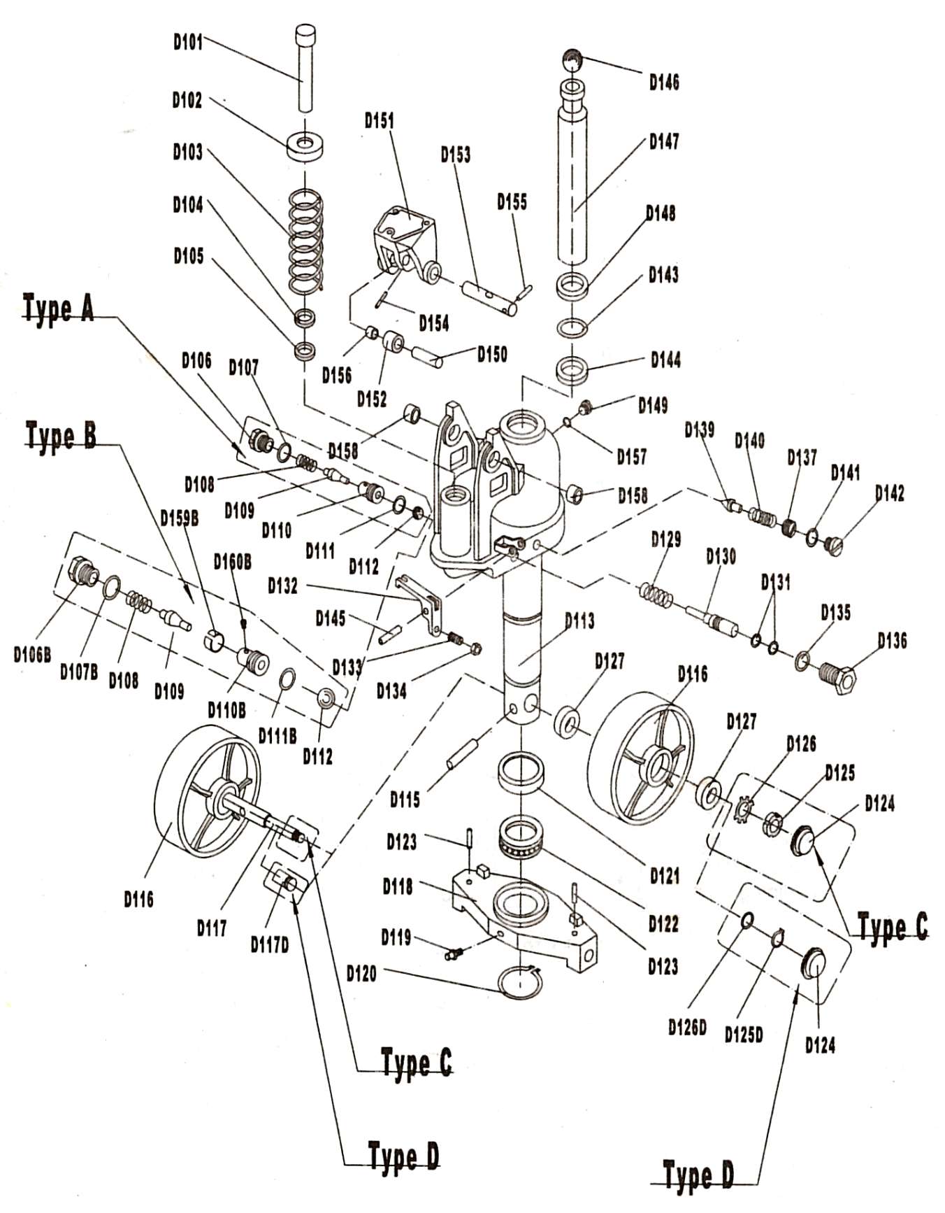
C-55 / ELP-55 / ALTRA

Châssis
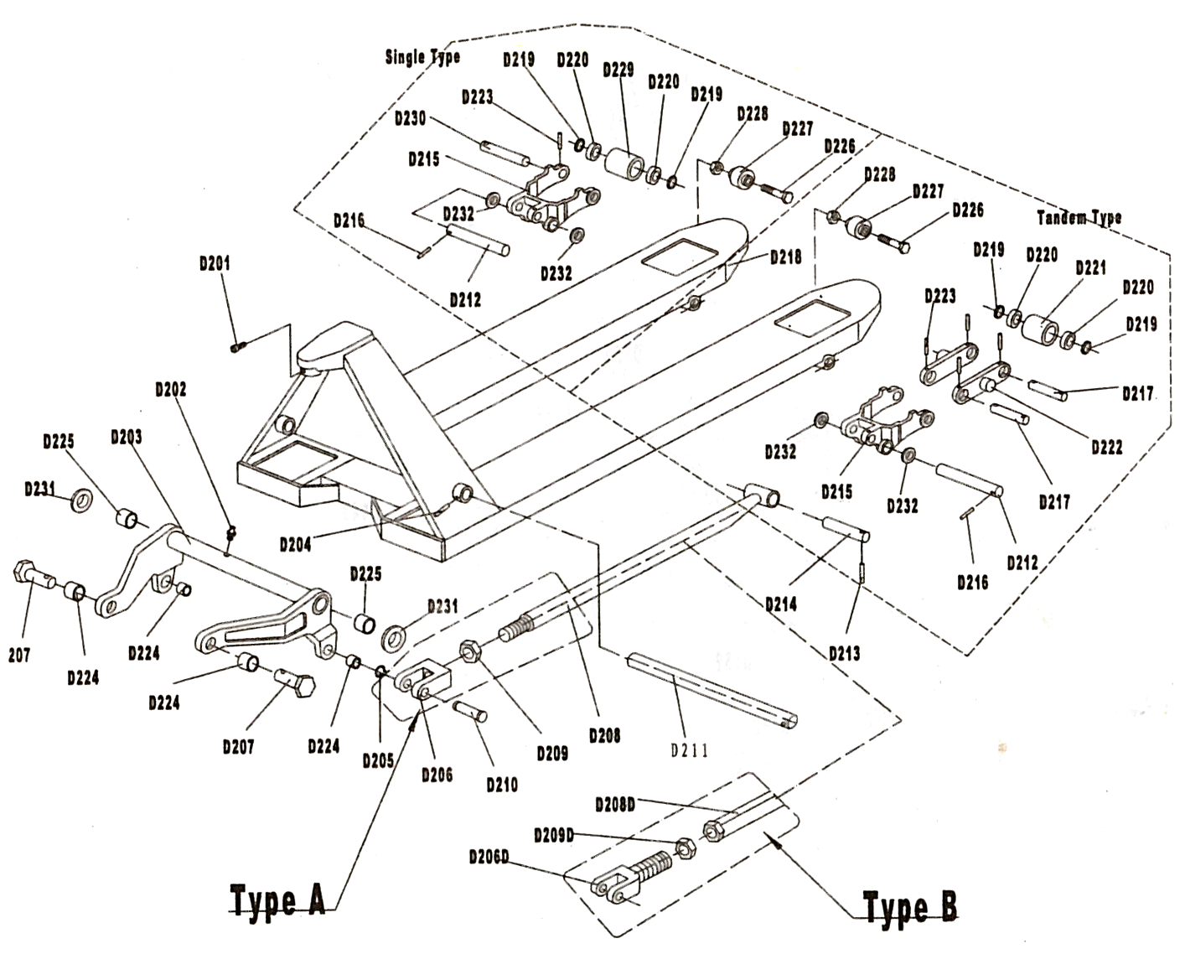

C-55 / ELP-55 / ALTRA

Poignée
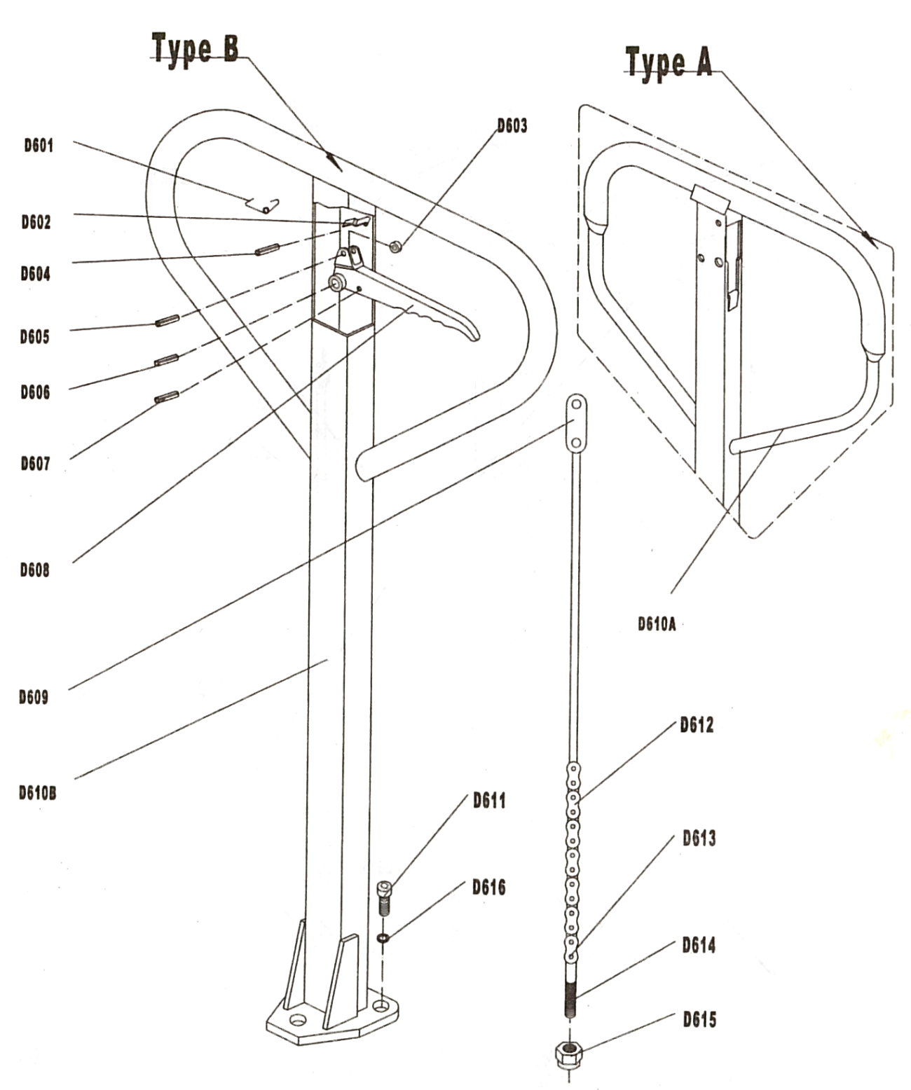

Dakota – SYBC

Unité hydraulique & Poignée
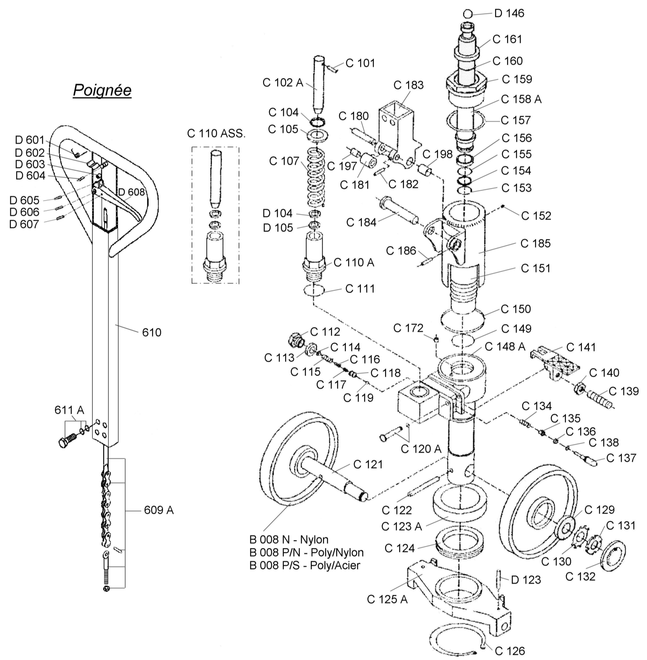

Dakota – SYBC

Châssis
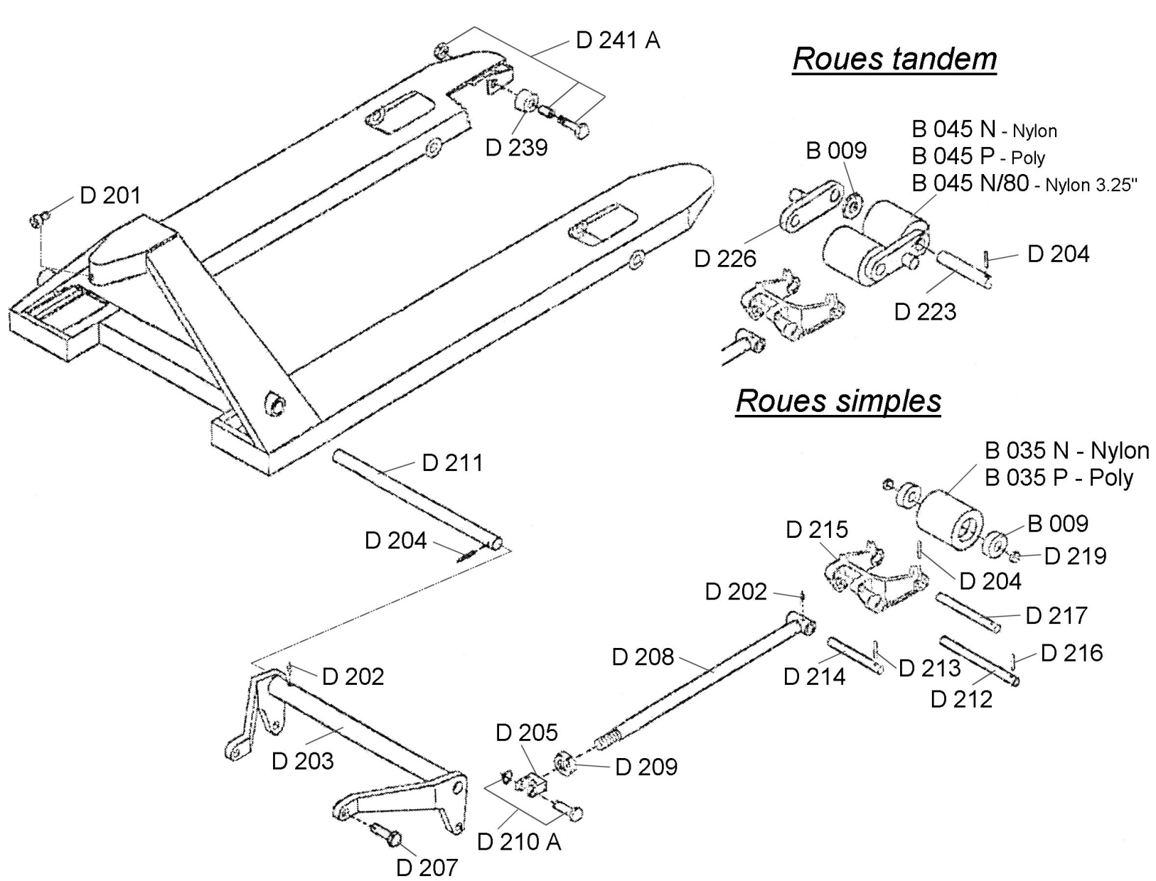

H-55

Unité hydraulique – Type A
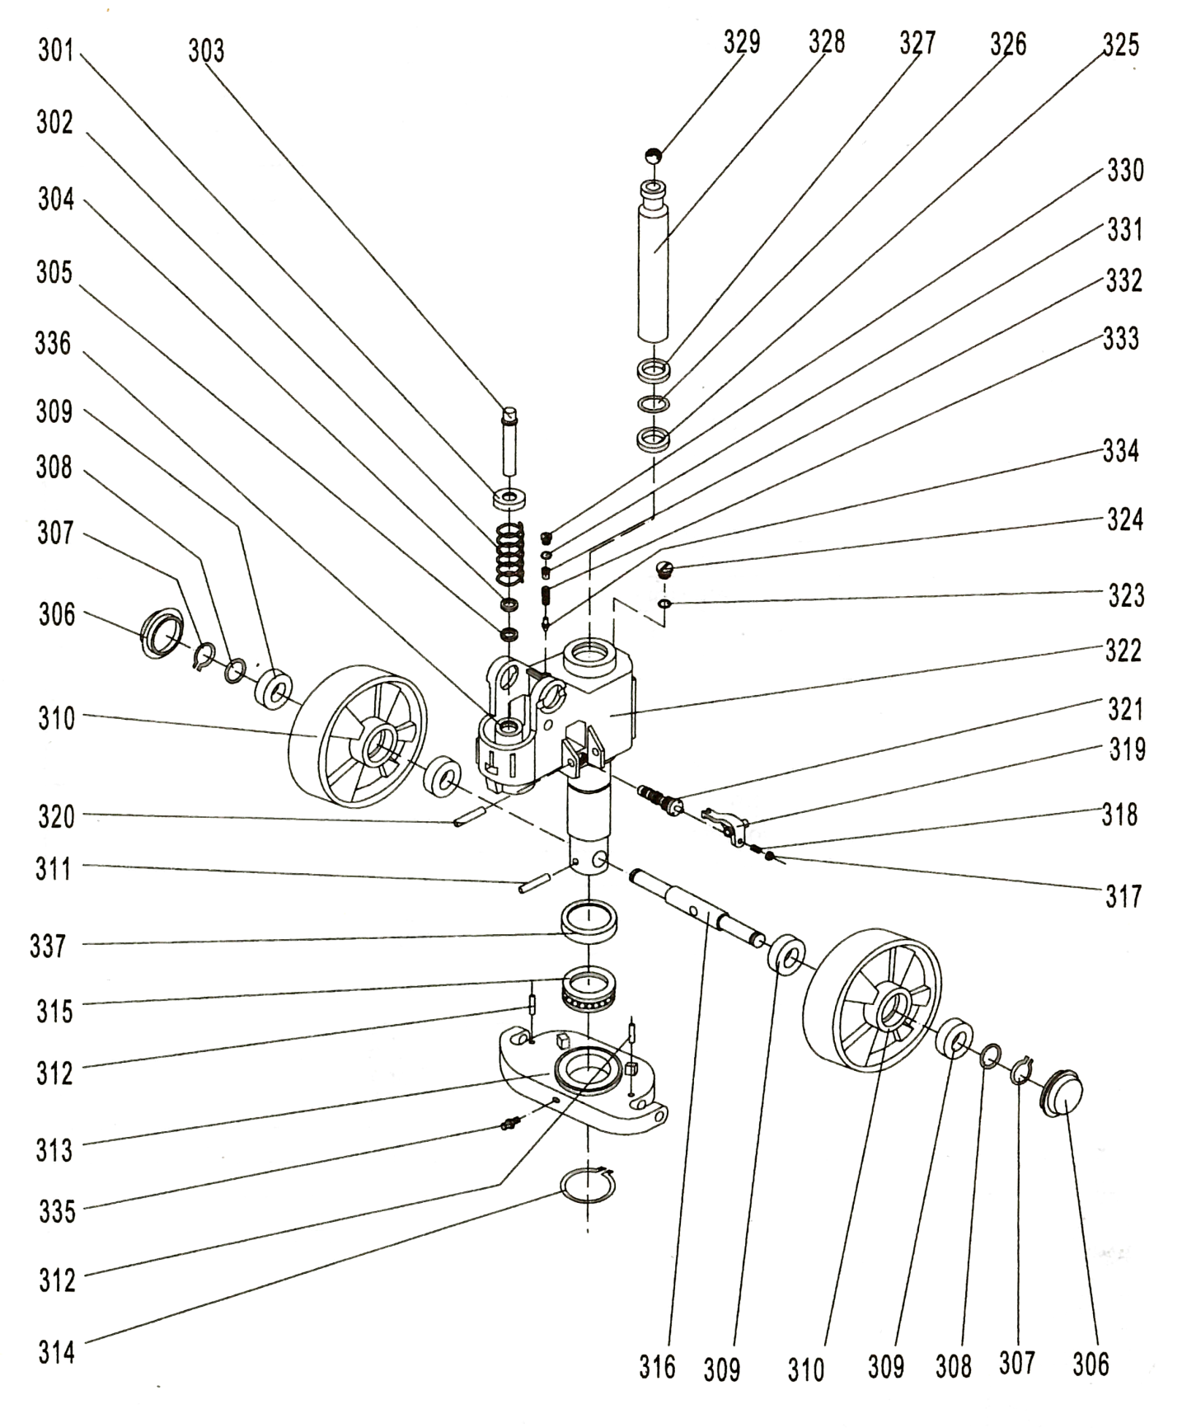

H-55

Unité hydraulique – Type Y
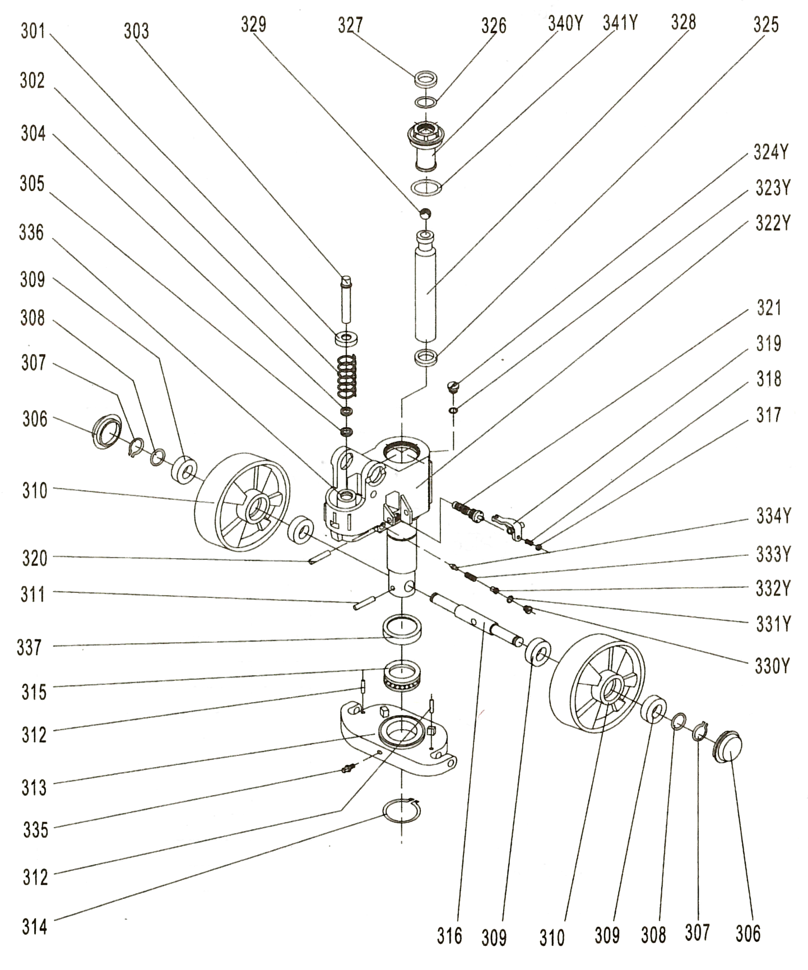

H-55

Unité hydraulique – Quick pompe
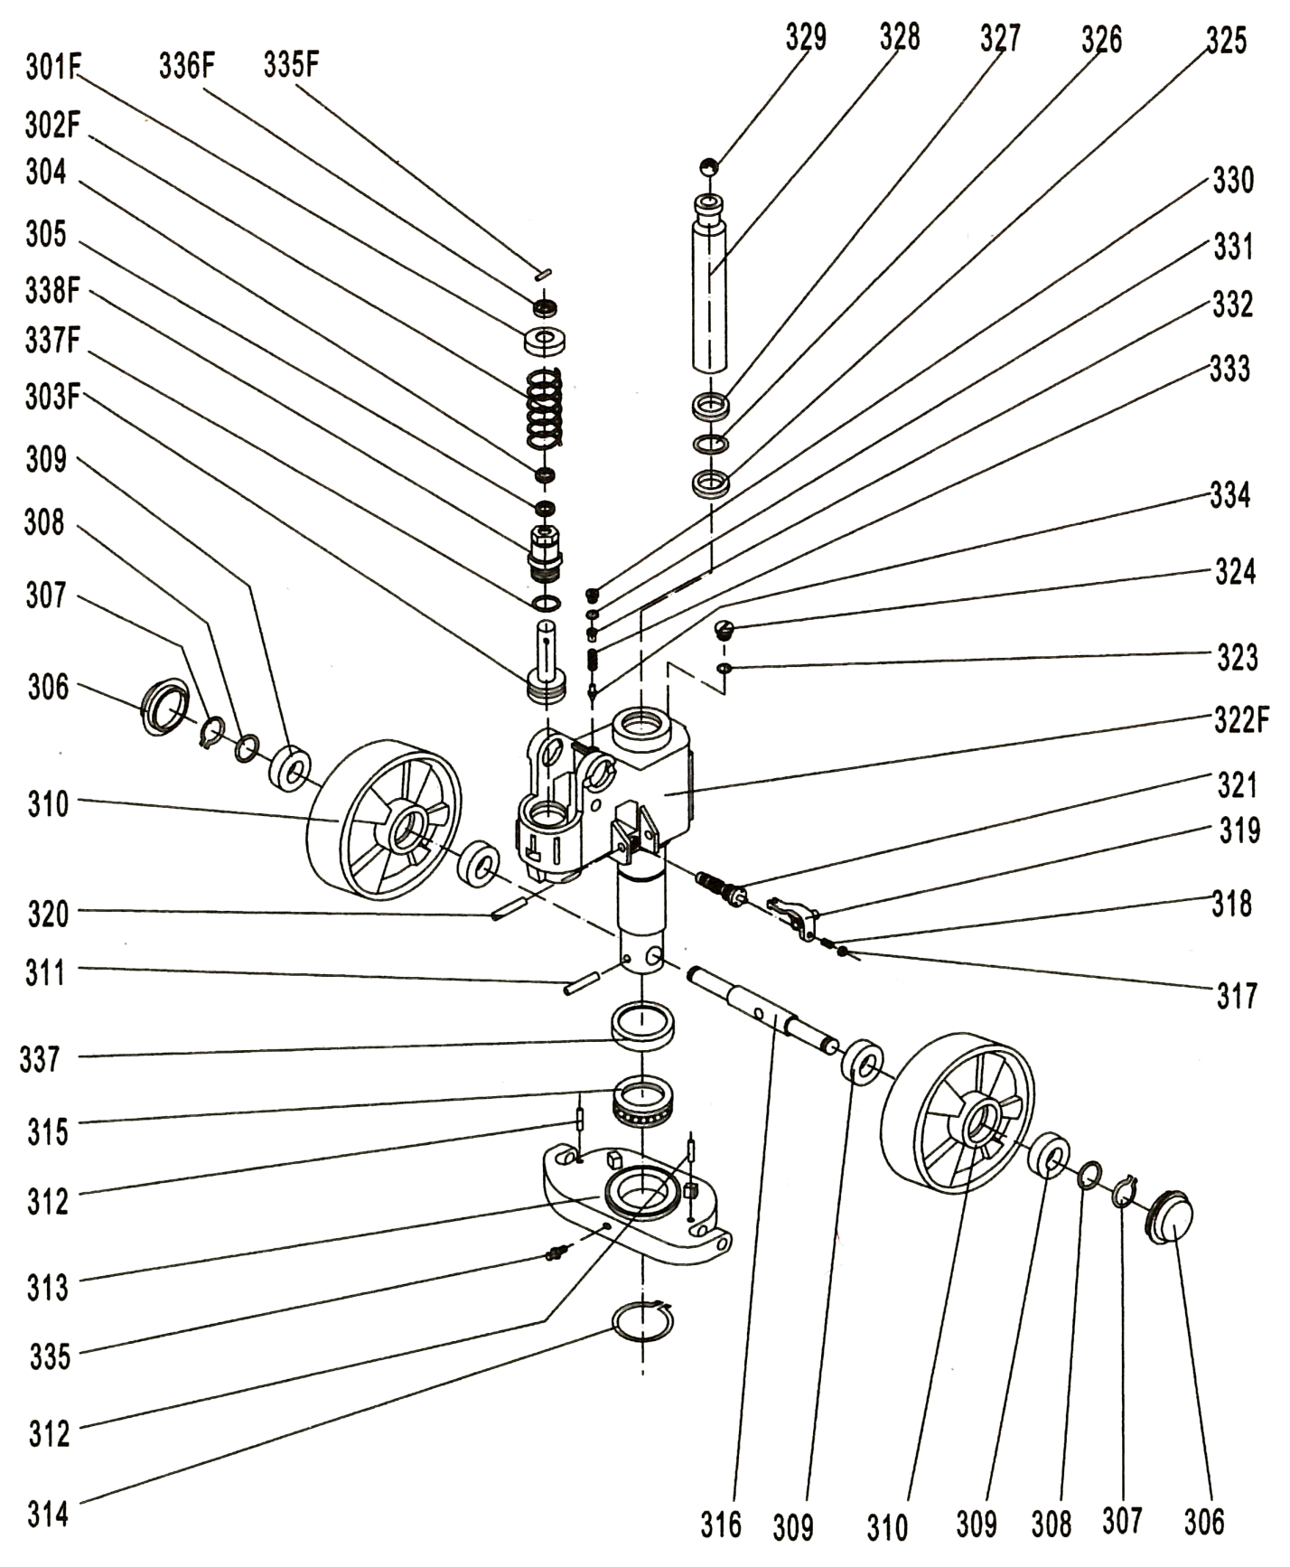

H-55

Châssis
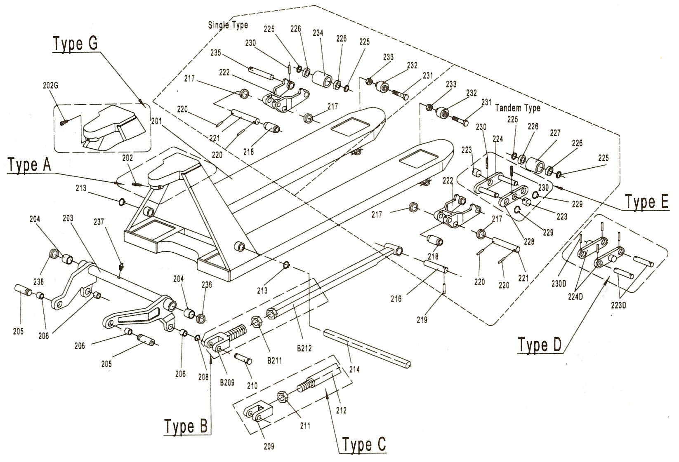

H-55

Poignée
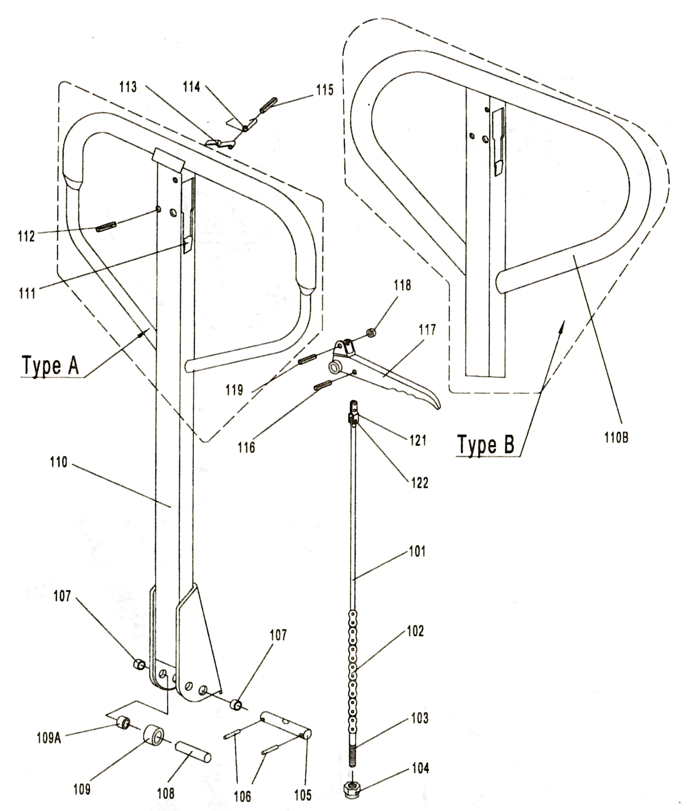

Lift-Rite – L50

Unité hydraulique & Poignée
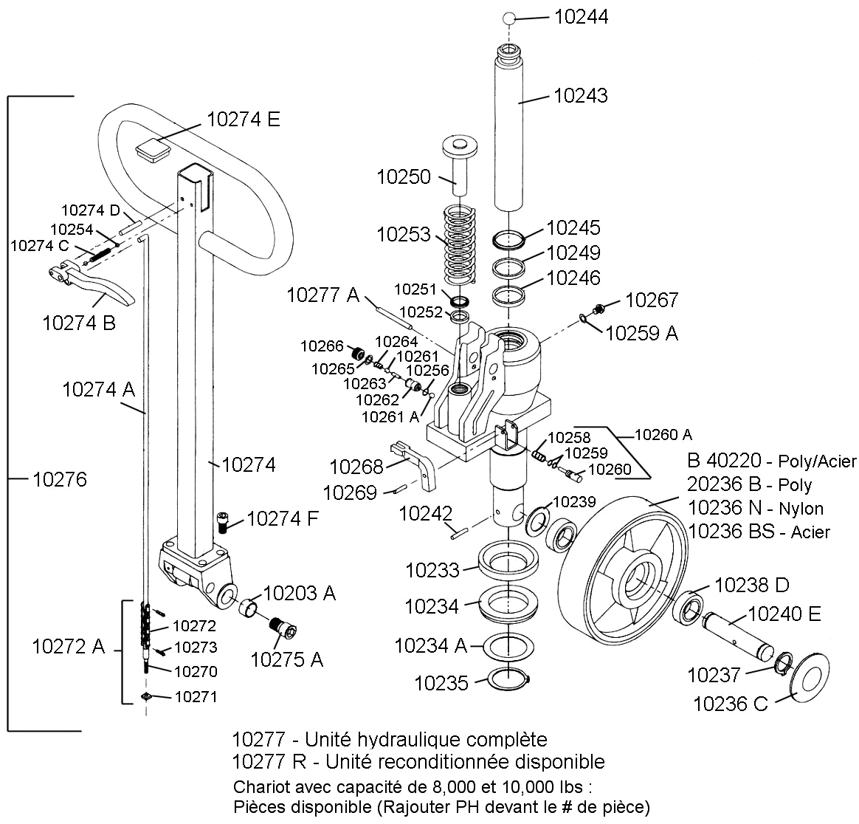

Lift-Rite – L50

Châssis
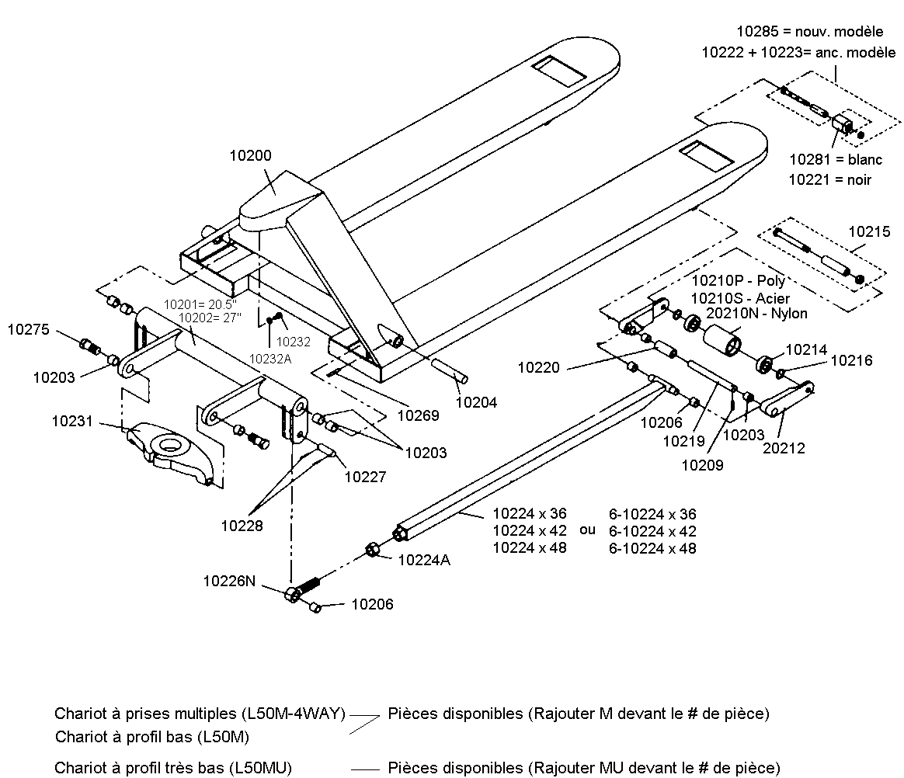

Lift-Rite – L50

Option roue tandem
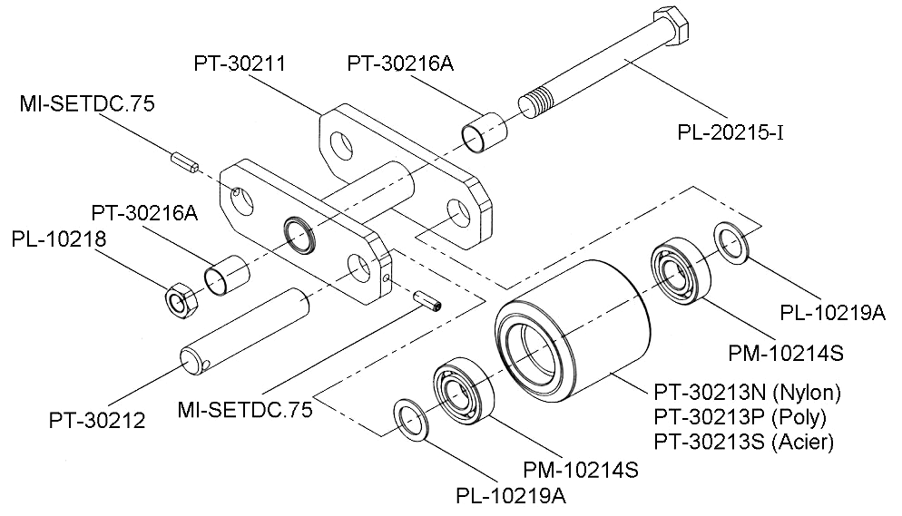

Option système de freins
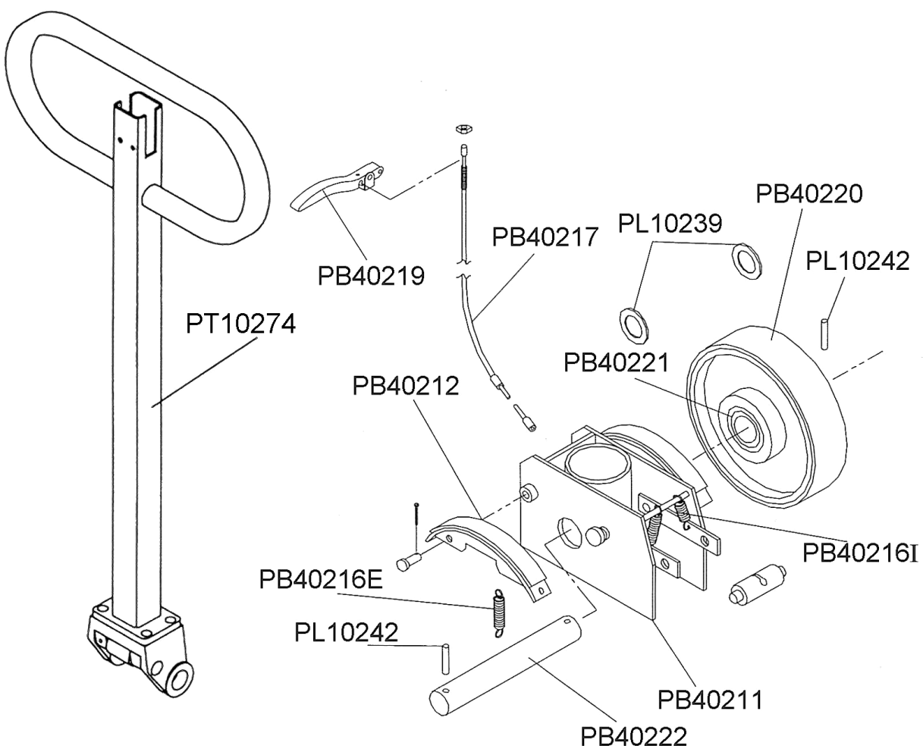

Lift-Rite – LR2055

Unité hydraulique
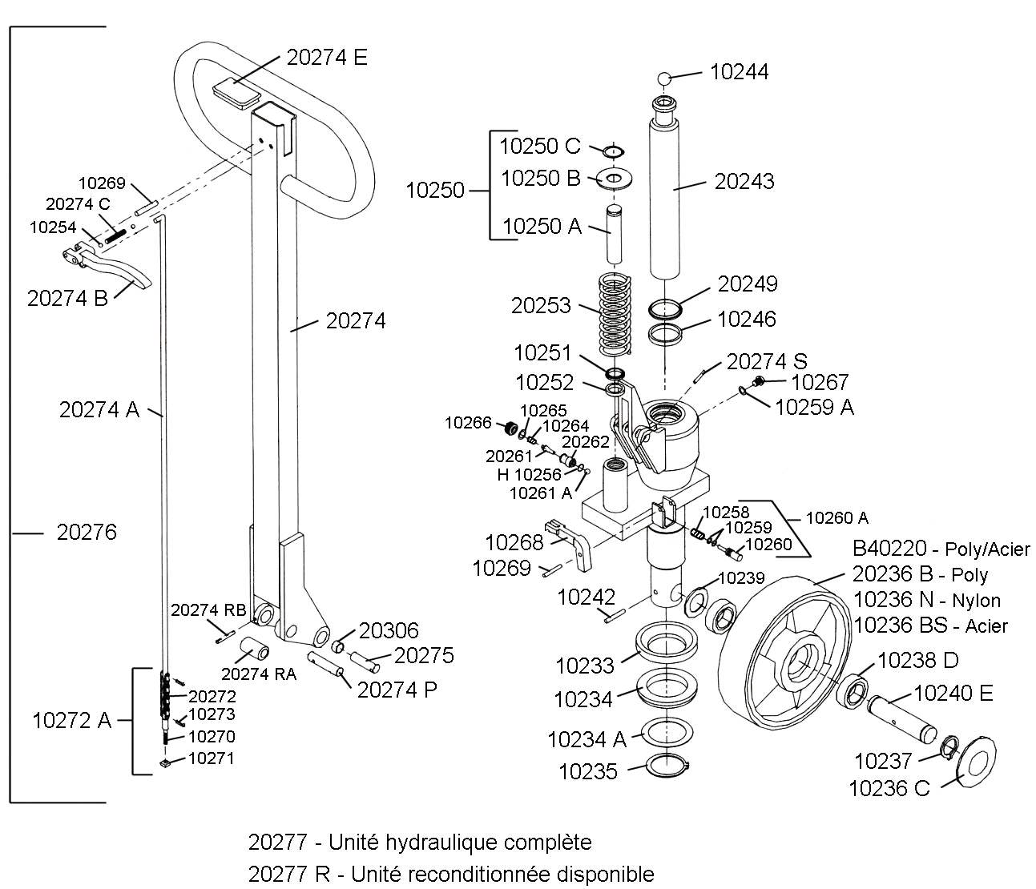

Lift-Rite – LR2055

Châssis
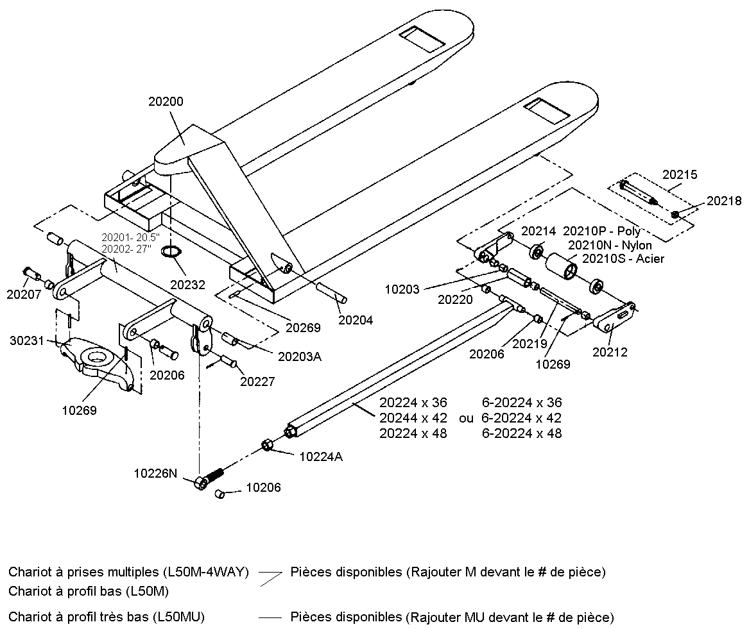

Lift-Rite – LR2055

Option roue tandem
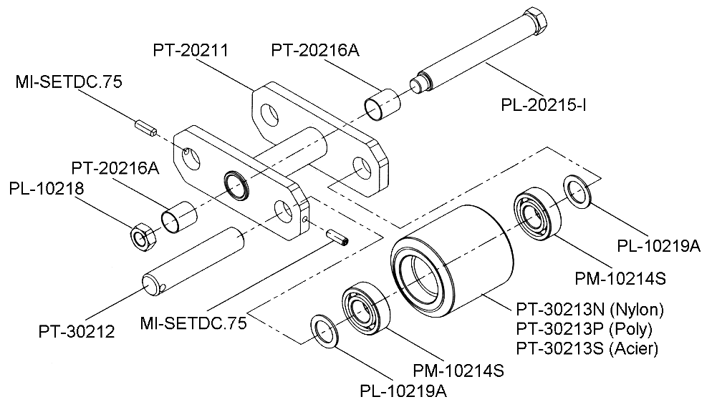

Option système de freins
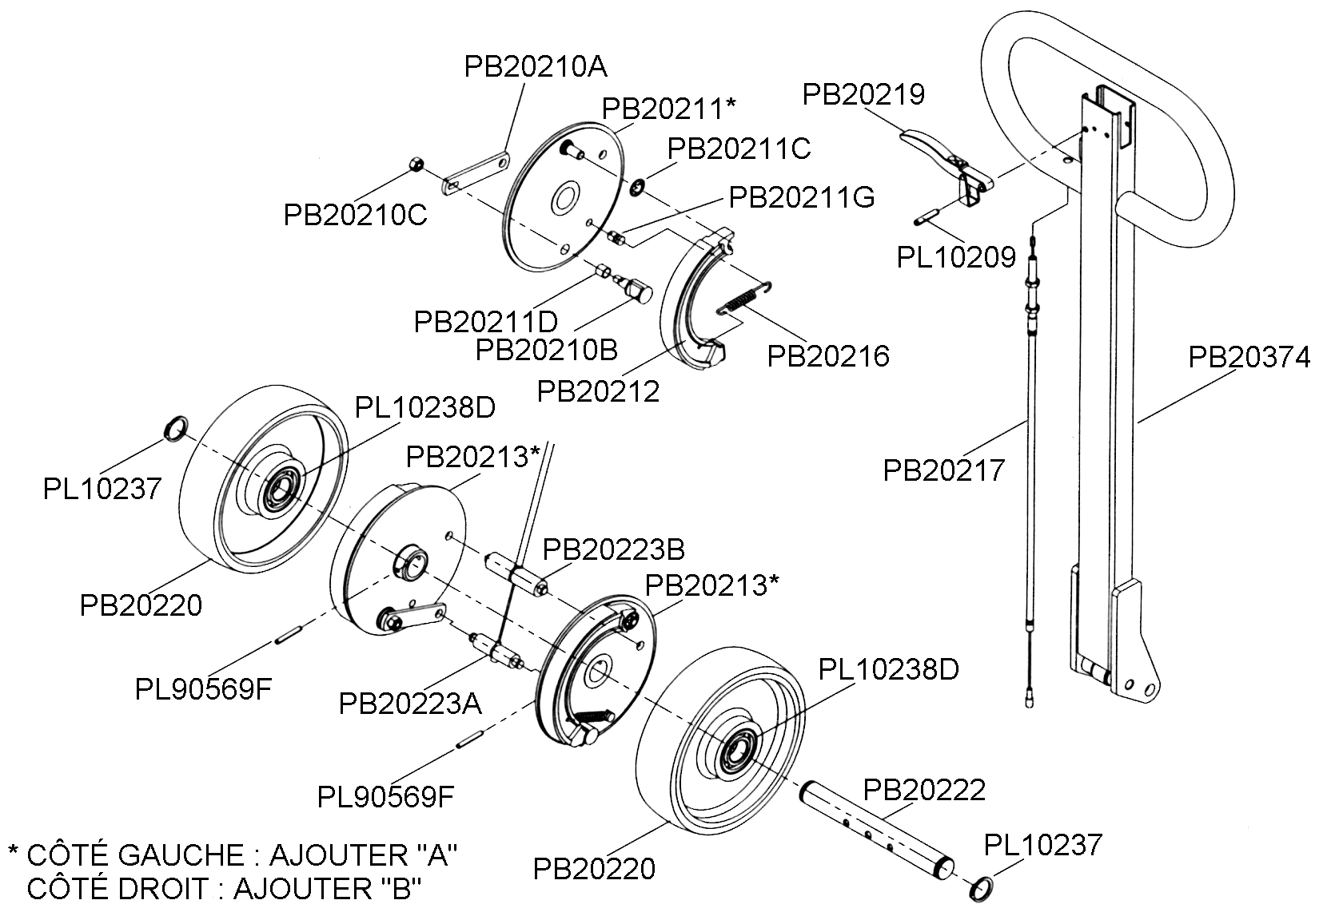

Lift-Rite – Titan LCR55 & LCS55

Unité hydraulique & Poignée
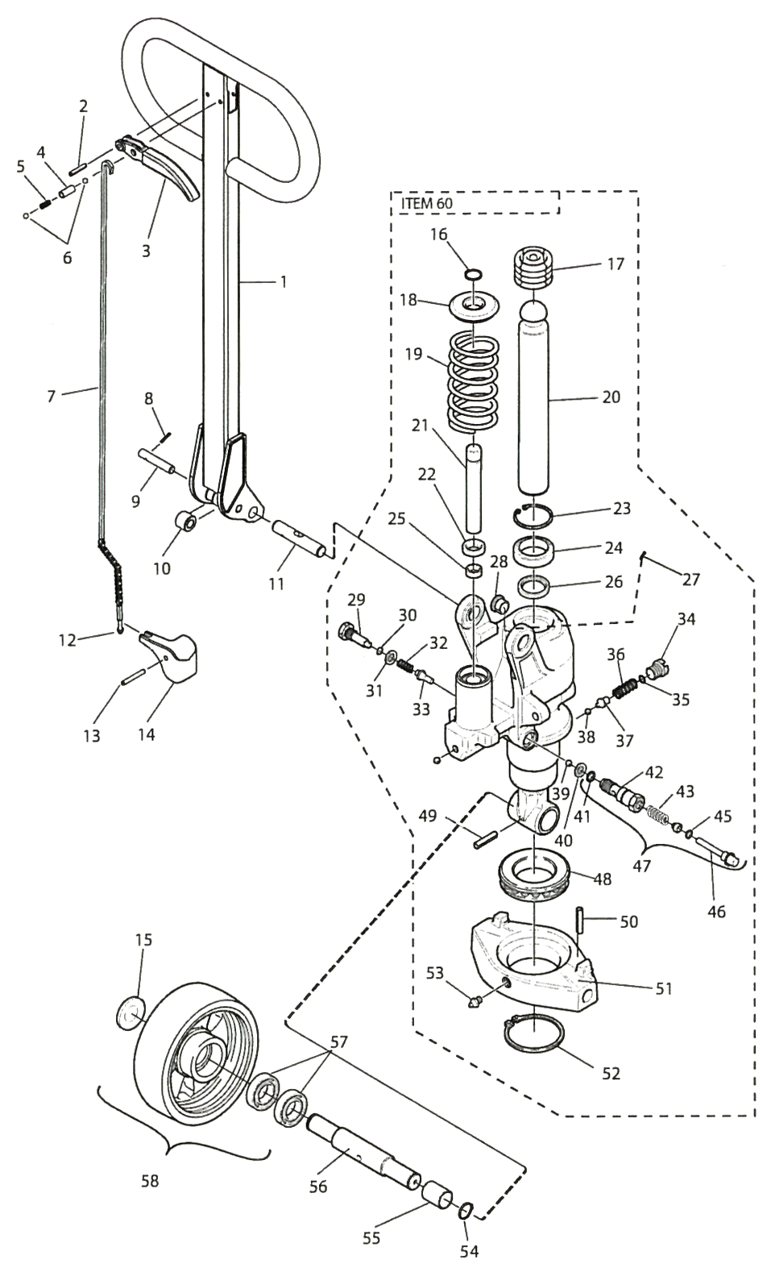 |  | 1 | PL-40276M
 |  | 2 | 20105
 |  | 3 | PL-40274BDM
 |  | 4 | 54140BT
 |  | 5 | 218182
 |  | 6 | 20065
 |  | 7 | 215775
 |  | 8 | 20461
 |  | 9 | 47930
 |  | 10 | 202755
 |  | 11 | 7500086
 |  | 12 | 21094
 |  | 13 | 220312
 |  | 14 | 215128
 |  | 15 | 156623BT
 |  | 16 | 20043
 |  | 17 | 215803
 |  | 18 | 215282
 |  | 19 | 215156
 |  | 20 | 215030
 |  | 21 | 215286
 |  | 22 | 21060
 |  | 23 | 20642
 |  | 24 | 20066
 |  | 25 | 215866
 |  | 26 | 215867
 |  | 27 | 20014
 |  | 28 | 215913
 |  | 29 | 221586
 |  | 30 | 24213
 |  | 31 | 219201
 |  | 32 | 39106
 |  | 33 | 223935
 |  | 34 | 221232
 |  | 35 | 22032
 |  | 36 | 221227
 |  | 37 | 221231
 |  | 38 | 22055
 |  | 39 | 20065
 |  | 40 | 215288
 |  | 41 | 22032
 |  | 42 | 7500112
 |  | 43 | 47071

45 | 7500100 |  | 52 | 21737 |  | 58 | 251186 (nylon)
46 | 7500116 |  | 53 | 27662 |  |  | 160422BT (poly)
47 | 7518604 |  | 54 | 20019 |  |  | 200965BT (poly/acier)
48 | 213056 |  | 55 | 161637 |  |  | 160433 (acier)
49 | 220312 |  | 56 | 220310 |  | 60 | 220069 (unité complète)
50 | 20001 |  | 57 | 22226 |  |  | 243772 (reconditionné)
51 | 215092

Lift-Rite –Titan LCR55

Châssis
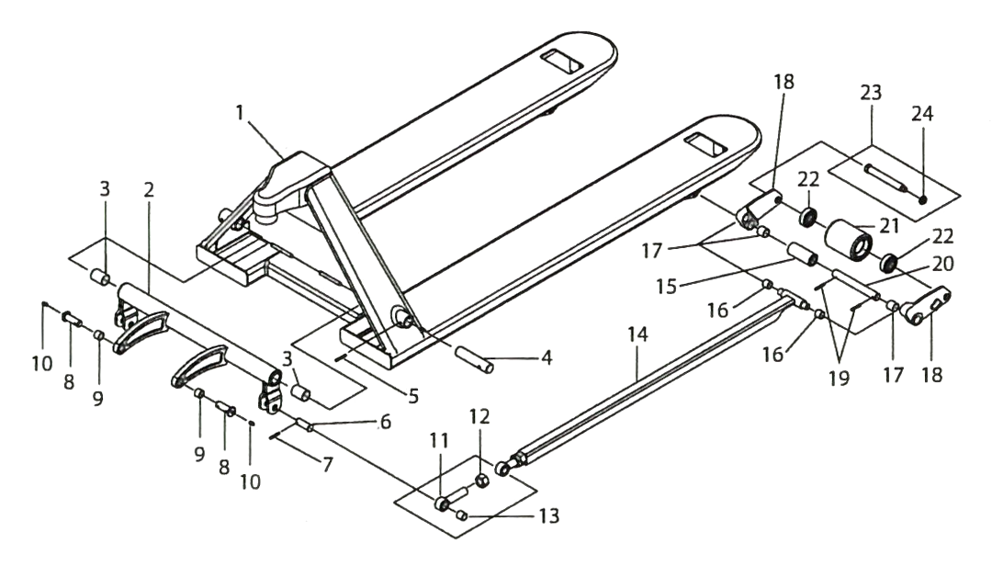

1 | PN-30200 |  | 10 | 27662 |  | 18 | PN-20212
2 | PN-30201 (larg. 20,5’’) |  | 11 | PN-20226 |  | 19 | PN-20269
 | PN-30202 (larg. 27’’) |  | 12 | PN-10224AF |  | 20 | PN-20219
3 | PN-20203A |  | 13 | PN-20226A |  | 21 | PL-20210BN-B (nylon)
4 | PN-20204 |  | 14 | PN-20224x36 (long. 36’’) |  |  | PL-20210P-B (poly)
5 | PN-20269A |  |  | PN-20224x42 (long. 42’’) |  |  | PL-20210S-BRG (acier)
6 | PN-20227 |  |  | PN-20224x48 (long. 48’’) |  | 22 | PL-20214
7 | PN-20269B |  | 15 | PN-20220 |  | 23 | PL-20215
8 | 166701 |  | 16 | PL-20206 |  | 24 | PL-10218
9 | PL-30206 |  | 17 | PN-20203

Lift-Rite –Titan LCS55

Châssis
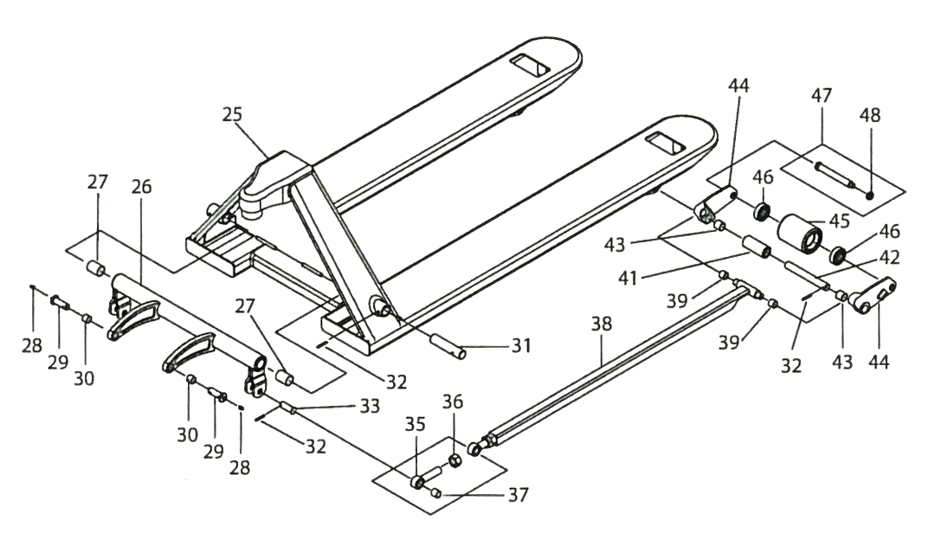

25 | PN-30200 |  | 35 | PL-20226 |  | 42 | PL-20219
26 | (Nous consulter) |  | 36 | PL-10224AF |  | 43 | PL-20203
27 | PN-20203A |  | 37 | PL-20226A |  | 44 | PL-20212
28 | 27662 |  | 38 | PL-20224x36 (long. 36’’) |  | 45 | PL-20210BN-B (nylon)
29 | 166701 |  |  | 1124207-002 (long. 60’’) |  |  | PL-20210P-B (poly)
30 | PL-30206 |  |  | 1124207-003 (long. 72’’) |  |  | PL-20210S-BRG (acier)
31 | PL-20204 |  |  | 1124210-002 (long. 96’’) |  | 46 | PL-20214
32 | PL-20269 |  | 39 | PL-20206 |  |  | PL-20215
33 | PL-20227 |  | 41 | PL-20220 |  |  | PL-10218

Lift-Rite – Ergo – RG-30E & RG-30M

Châssis
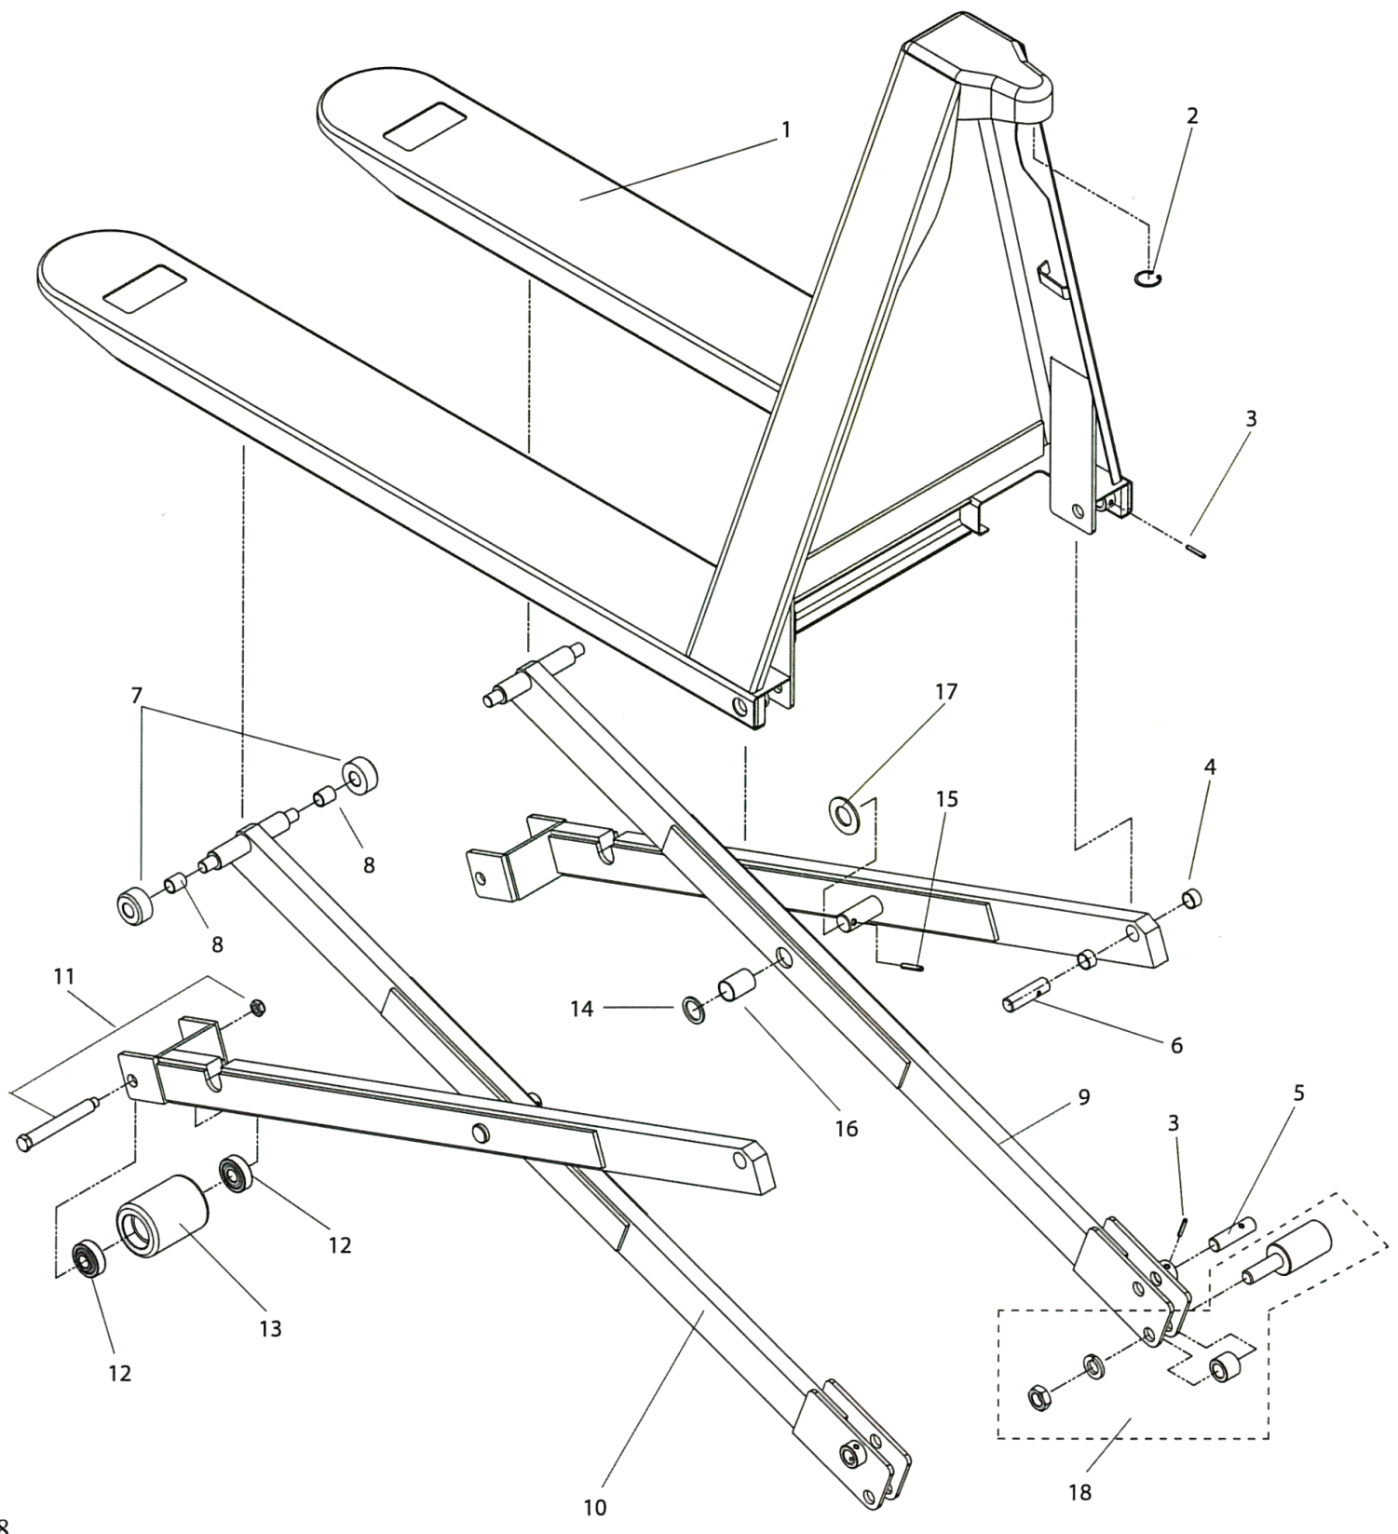
1 | PR-8021A (larg 27’’) |  | 7 | PR-8007 |  | 13 | PL-20210P-B (poly)
 | PR-80212 (larg. 20,5’’) |  | 8 | PR-8007A |  |  | PL-20210S-B (acier)
2 | PL-20232 |  | 9 | 1125955 (droit) |  | 14 | PL-10239
3 | PL-10269 |  | 10 | 1125956 (gauche) |  | 15 | PL-10242
4 | PL-10203A |  | 11 | PL-20215-I |  | 16 | PR-8516
5 | PR-8012/8013 (int.) |  | 12 | PL-20214 |  | 17 | PL-10242
6 | PR08012/8013 (ext.) |  | 13 | PL-20210BN-B (nylon) |  | 18 | PR-8010

Lift-Rite – Ergo – RG-30E & RG-30M

Plaque d’appui
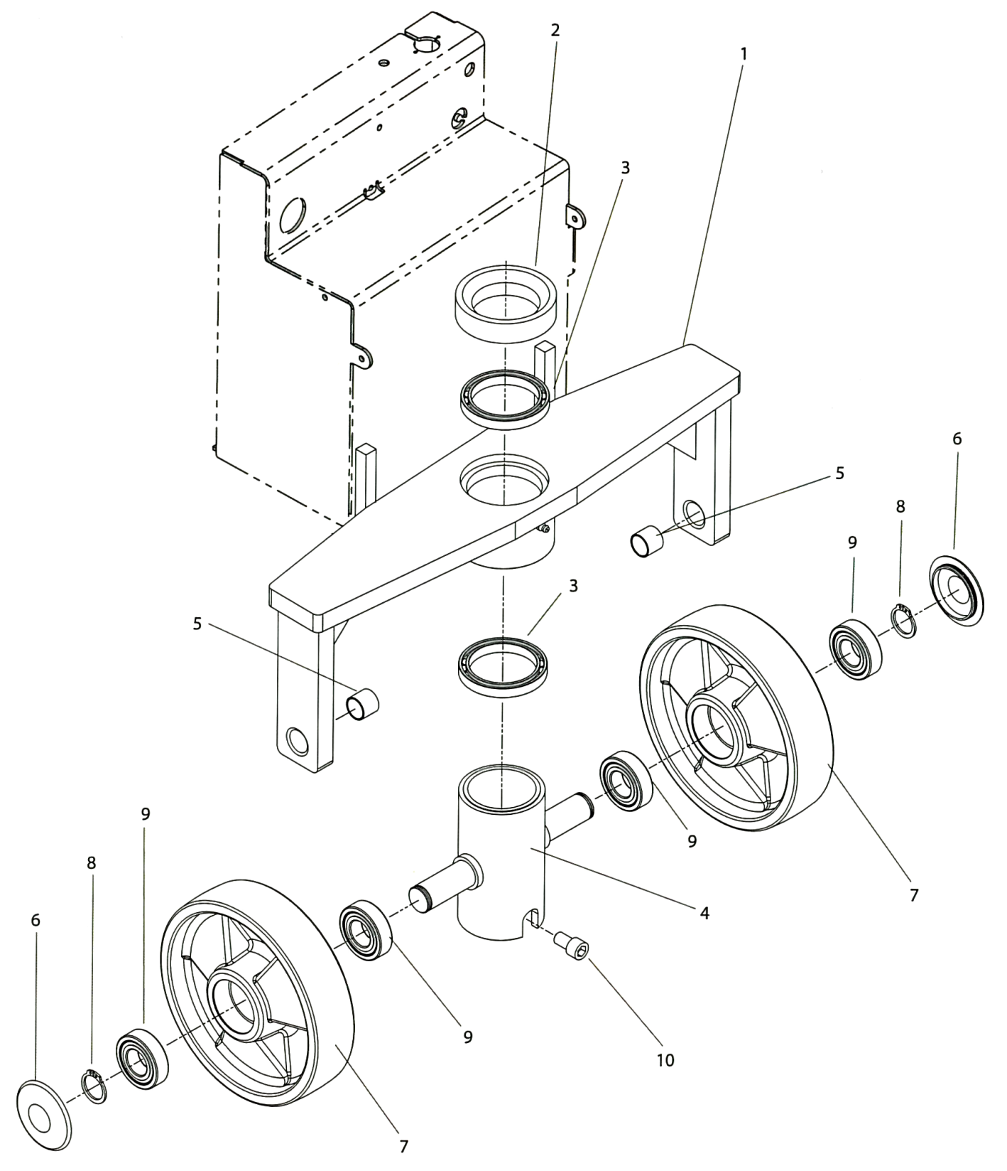
1 | PR-8024AE (27’’ – manuel) |  | 4 | PR-8031A |  | 8 | PL-10237
 | 1130181/001 (27’’ – électr.) |  | 5 | PL-10203 |  | 9 | PL-10238D
 | PR-8024BE (20,5’’ – manuel) |  | 6 | PL-10236C |  | 10 | PR-8518
 | 1130181/002 (20,5’’ – électr.) |  | 7 | PL-20236BN-B (nylon)
2 | PR-8030 |  |  | PL-20236B-B (poly)
3 | PR-8512 |  |  | PR-102368S-B (acier)

Lift-Rite – Ergo – RG-30E

Unité hydraulique & Poignée
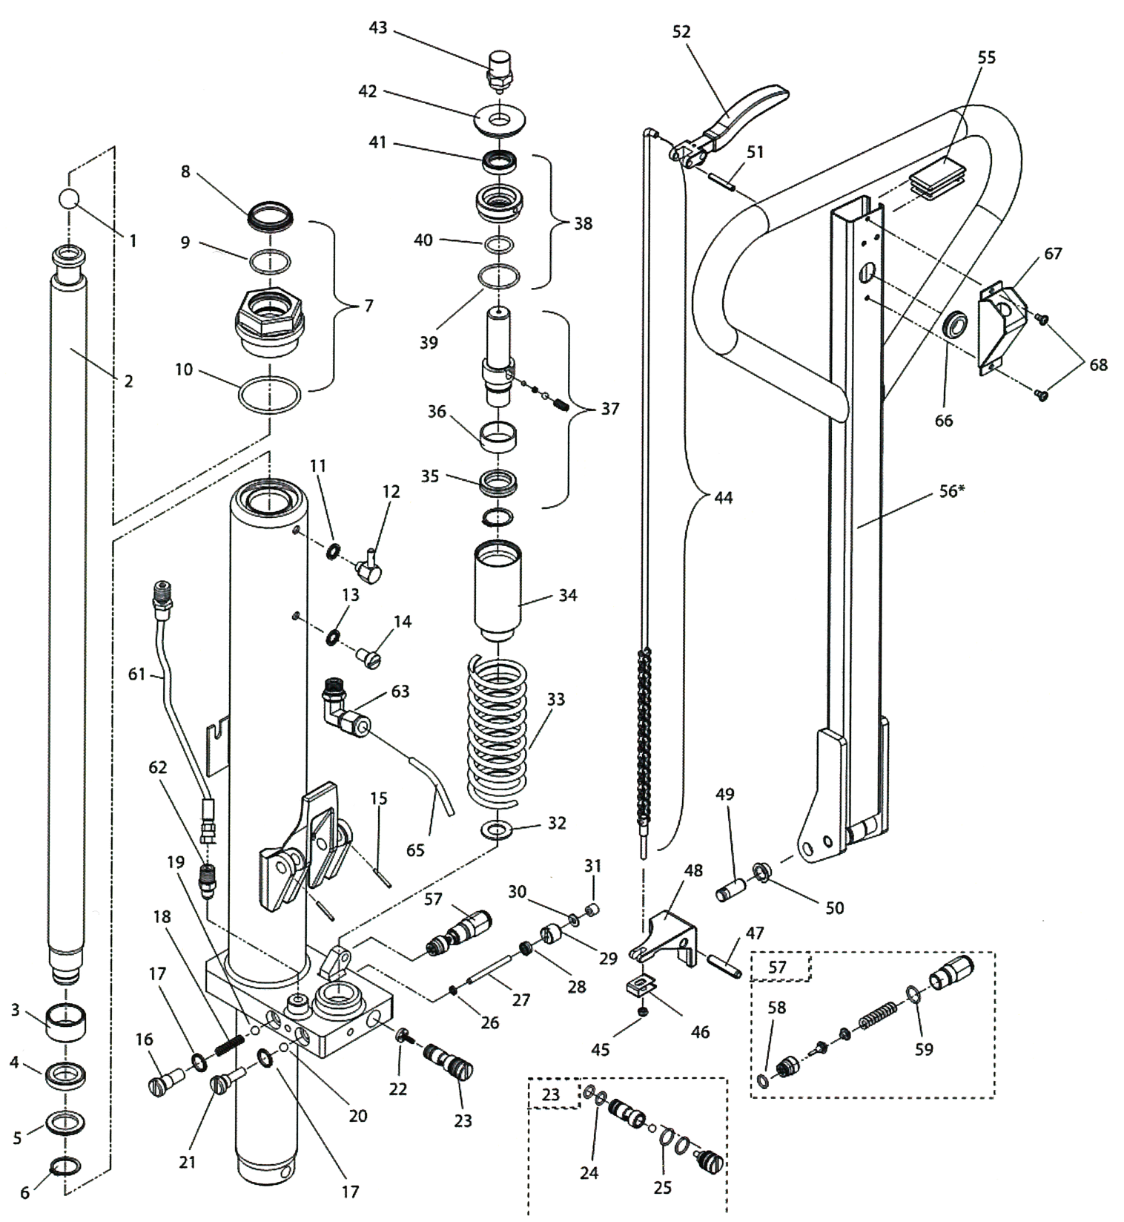

Voir page suivante pour les numéros de pièces

1 | PL-10244 |  | 23 | PR-8548 |  | 45 | PL-90571
2 | PR-8530A |  | 24 | PR-8548B |  | 46 | PR-8519
3 | PR-8538 |  | 25 | PR-8548A |  | 47 | PR-8559
4 | PR-8539 |  | 26 | PR-8551 |  | 48 | PR-8559
5 | PR-8540 |  | 27 | PR-8554 |  | 49 | PL-20275
6 | PR-8541 |  | 28 | PR-8552 |  | 50 | PL-20306
7 | PR-8529 |  | 29 | PR-8553 |  | 51 | PL-90569E
8 | PR-8529A |  | 30 | PR-8555 |  | 52 | PL-20274BD-M
9 | PR-8529B |  | 31 | PR-8556 |  | 55 | PL-20274E
10 | PR-8529C |  | 32 | PR-8537 |  | 56 | PR-20274TDE
11 | PR-8582A |  | 33 | PR-8533 |  | 57 | PR-8557
12 | PR-8582 |  | 34 | PR-8536 |  | 58 | PR-8557B
13 | PR-8528 |  | 35 | PR-8534B |  | 59 | PR-8557A
14 | PR-8527 |  | 36 | PR-8534A |  | 61 | 1143999
15 | PR-20274S |  | 37 | PR-8534 |  | 62 | PR-8563
16 | PR-8542 |  | 38 | PR-8535 |  | 63 | 1144002/001
17 | PR-8543 |  | 39 | PR-8535C |  | 65 | PR-8048
18 | PR-8544 |  | 40 | PR-8535B |  | 66 | PC-9066A
19 | PR-8545 |  | 41 | PR-8535A |  | 67 | PR-8048
20 | PR-8546 |  | 42 | PR-8532 |  | 68 | MI-SCW10-375
21 | PR-8547 |  | 43 | PR-8531 |  | 69 | PR-8575 (valve kit)
22 | PR-8549 |  | 44 | PR-20274AC-M |  | 70 | PR-8577 (seal kit)

Lift-Rite – Ergo – RG-30E

Composantes électriques
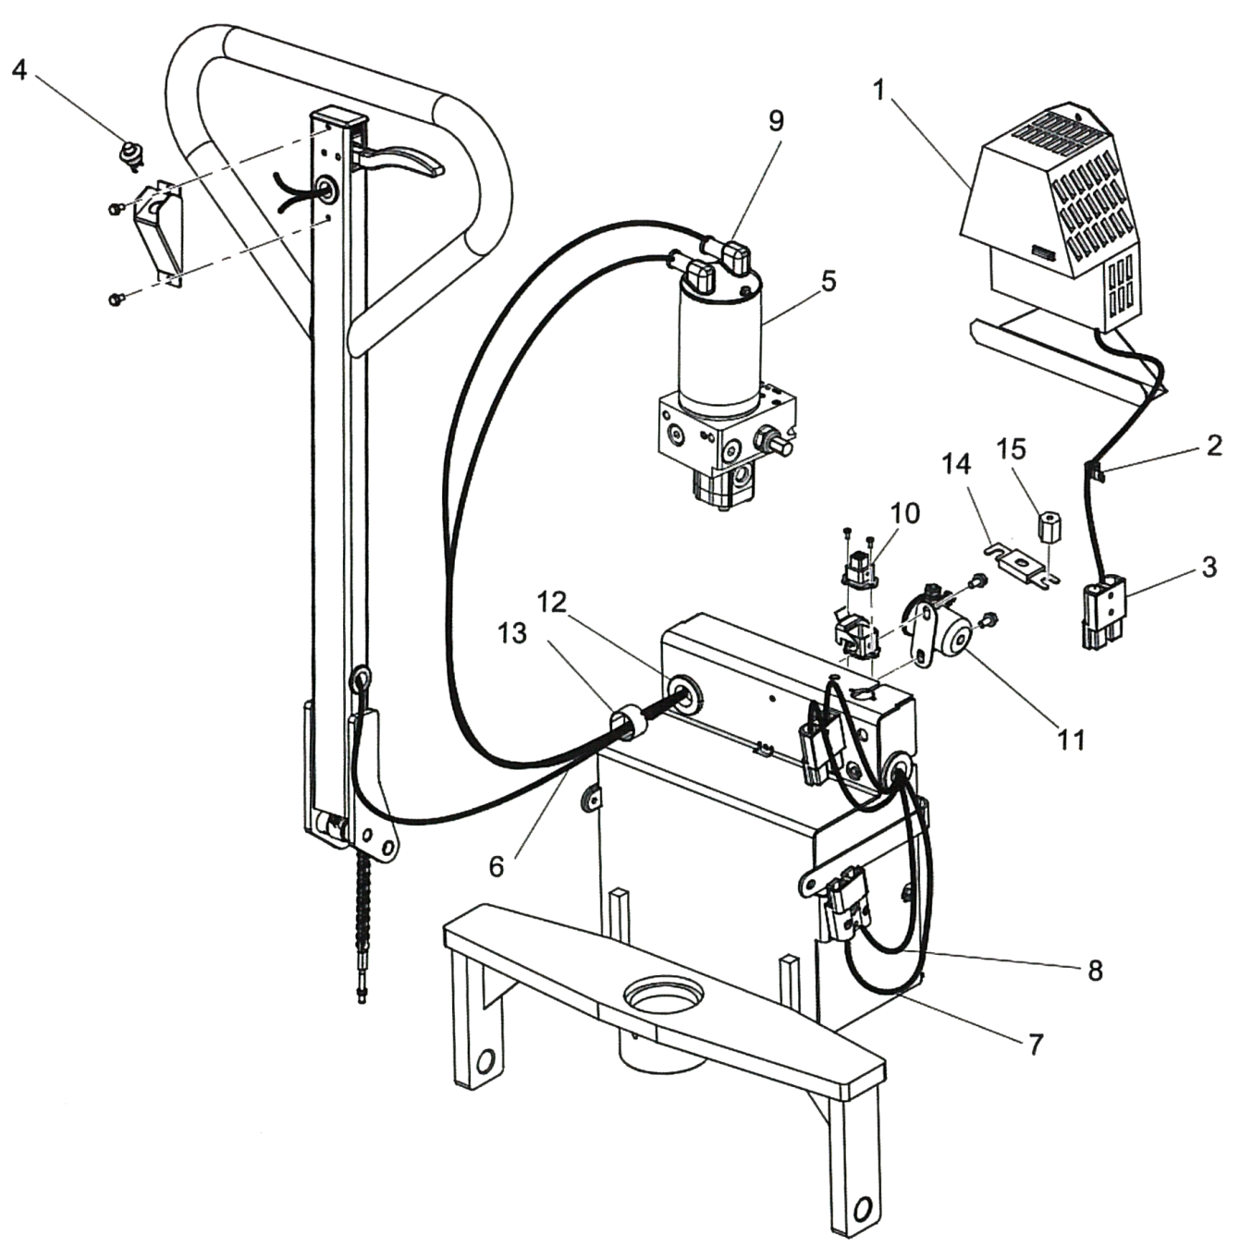

1 | 1134731 |  | 7 | 1099187/018 |  | 13 | 15677-1
2 | _1-074-087/005 |  | 8 | 1099187/019 |  | 14 | 590-587/105
3 | 49854-09 |  | 9 | 301253-000 |  | 15 | 307371-000
4 | PC-3017 |  | 10 | 1130732 |  | 17 | PR-8574
5 | 1143776 |  | 11 | 22226-02
6 | 1130733 |  | 12 | 11813-23

Lift-Rite – Ergo – RG-30M

Unité hydraulique & Poignée
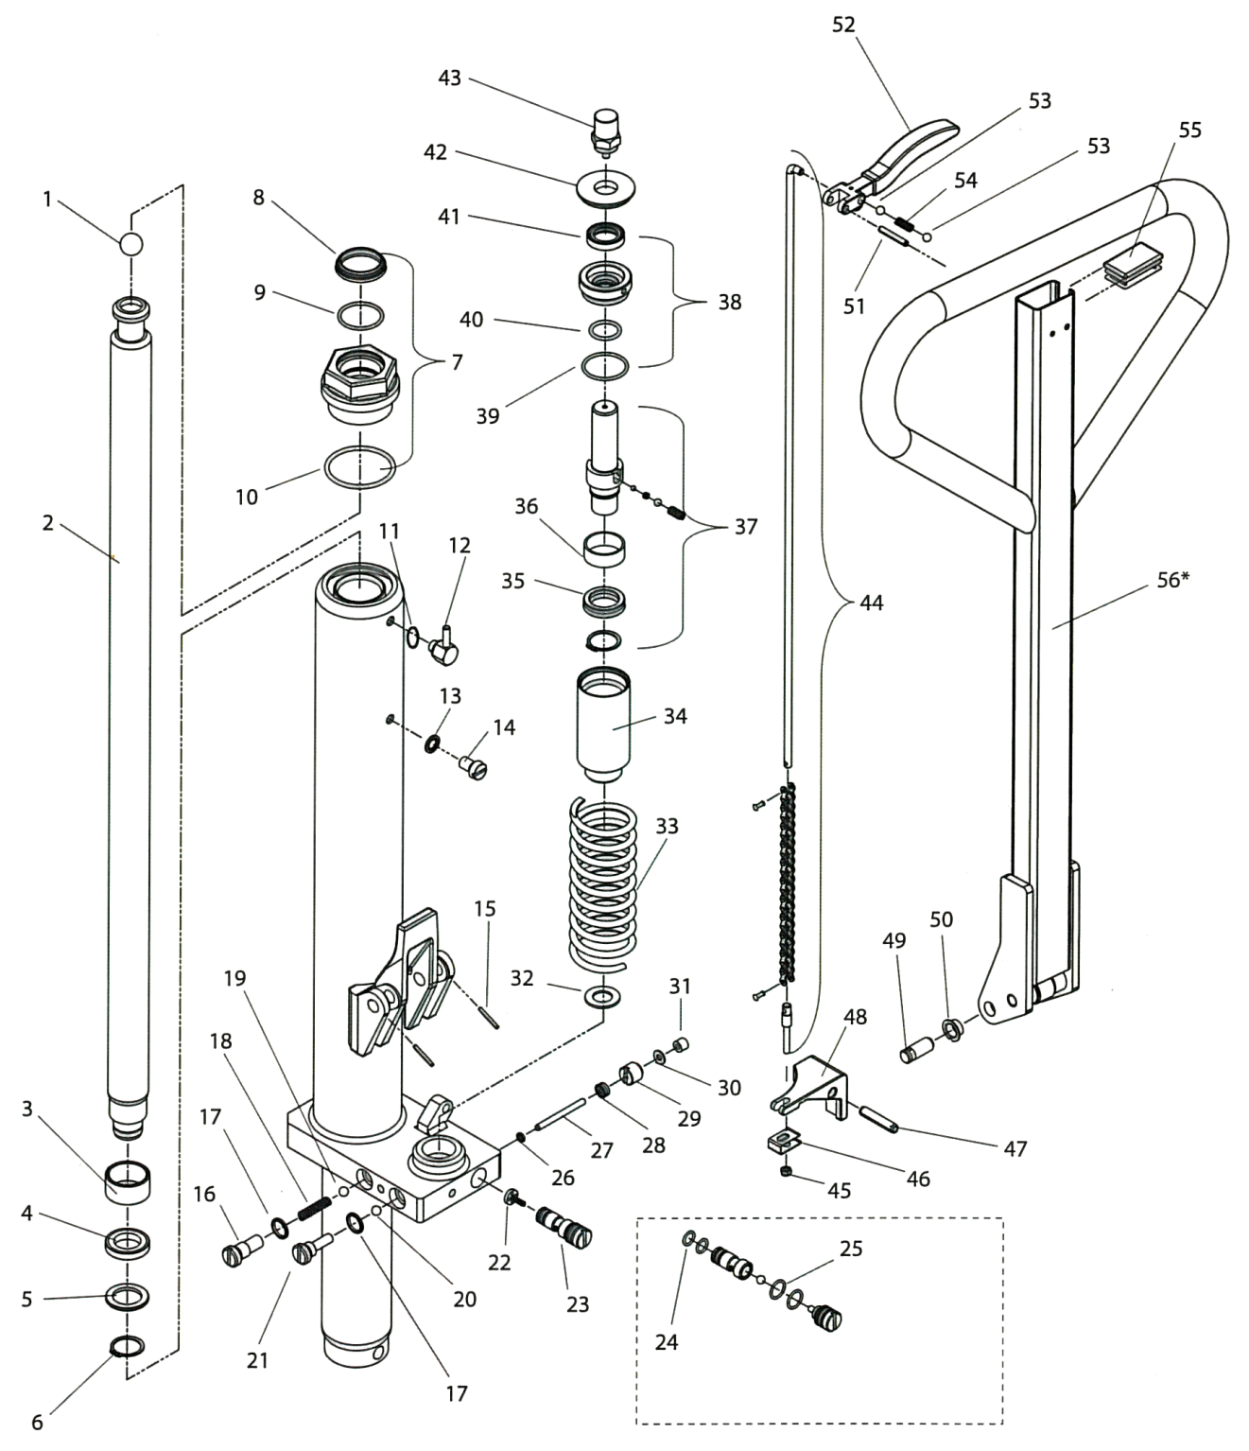

Voir page suivante pour les numéros de pièces

1 | PL-10244 |  | 21 | PR-8547 |  | 40 | PR-8535B
2 | PR-8530A |  | 22 | PR-8549 |  | 41 | PR-8535A
3 | PR-8538 |  | 23 | PR-8548 |  | 42 | PR-8532
4 | PR-8539 |  | 24 | PR-8548B |  | 43 | PR-8531
5 | PR-8540 |  | 25 | PR-8548A |  | 44 | PR-20274ACM
6 | PR-8541 |  | 26 | PR-8551 |  | 45 | PL-90571
7 | PR-8529 |  | 27 | PR-8554 |  | 46 | PR-8519
8 | PR-8529A |  | 28 | PR-8552 |  | 47 | PR-8559
9 | PR-8529B |  | 29 | PR-8553 |  | 48 | PR-8558
10 | PR-8529C |  | 30 | PR-8555 |  | 49 | PL-20275
11 | PR-8582A |  | 31 | PR-8556 |  | 50 | PL-20306
12 | PR-8582 |  | 32 | PR-8537 |  | 51 | PL-102169
13 | PR-8528 |  | 33 | PR-8533 |  | 52 | PL-20274BD
14 | PR-8527 |  | 34 | PR-8536 |  | 53 | PL-10254
15 | PL-20274S |  | 35 | PR-8534B |  | 54 | PL-20274C
16 | PR-8542 |  | 36 | PR-8534A |  | 55 | PL-20274E
17 | PR-8543 |  | 37 | PR-8534 |  | 56 | PR-20274TDM
18 | PR-8544 |  | 38 | PR-8535 |  | 57 | PR-8575
19 | PR-8545 |  | 39 | PR-8535C |  | 58 | PR-8577
20 | PR-8546

Mahaffy – Wrangler

Unité hydraulique
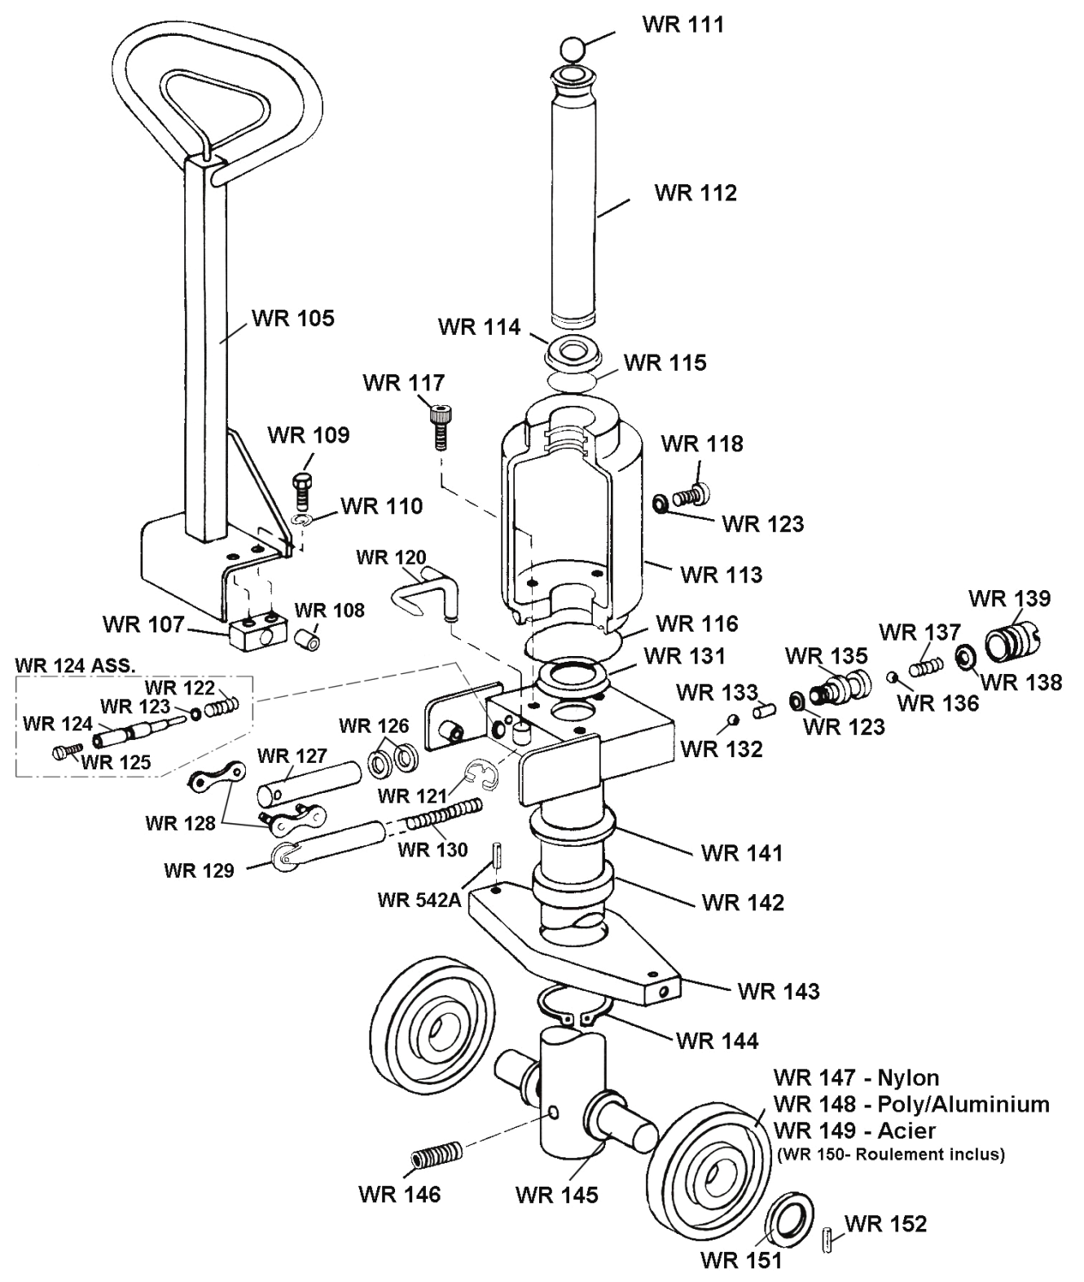
WR 155 | Unité hydraulique complète
WR 155R | Unité reconditionnée disponible

Mahaffy – Wrangler

Châssis
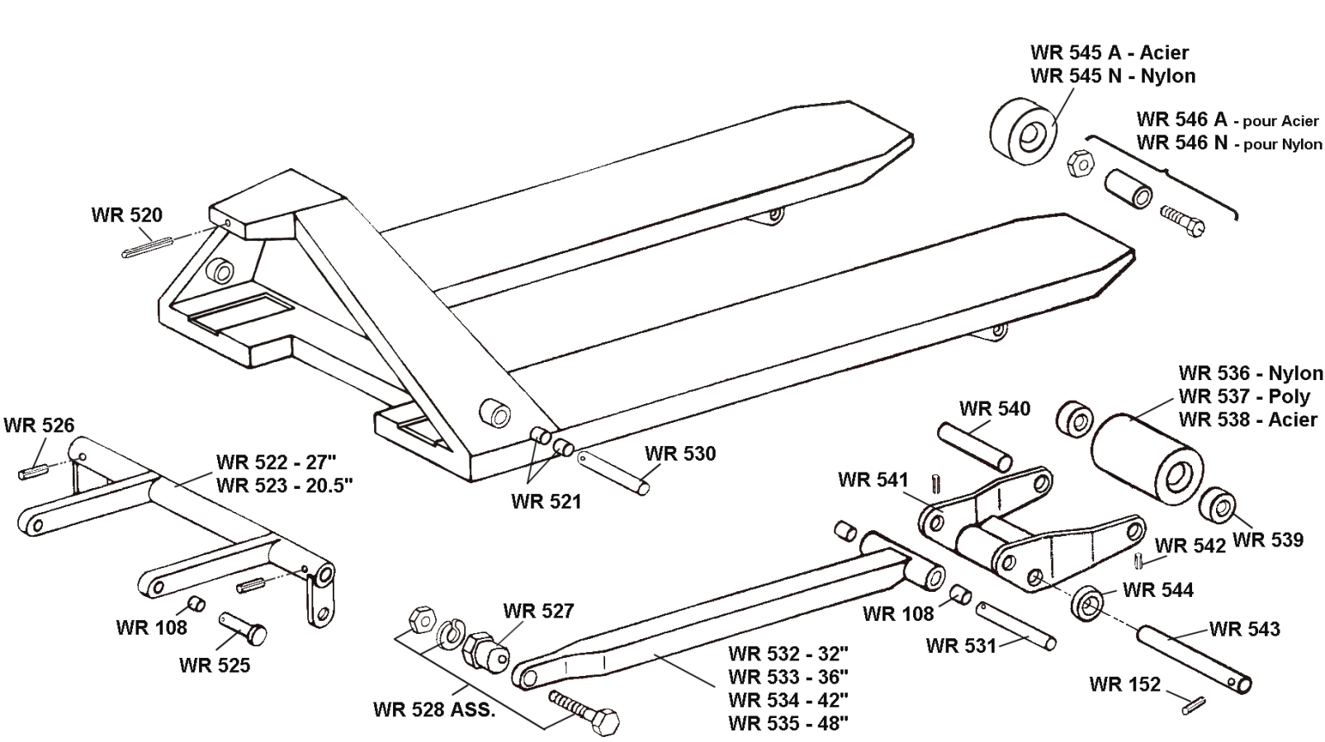

Mobile – ML50 et ML55

Châssis
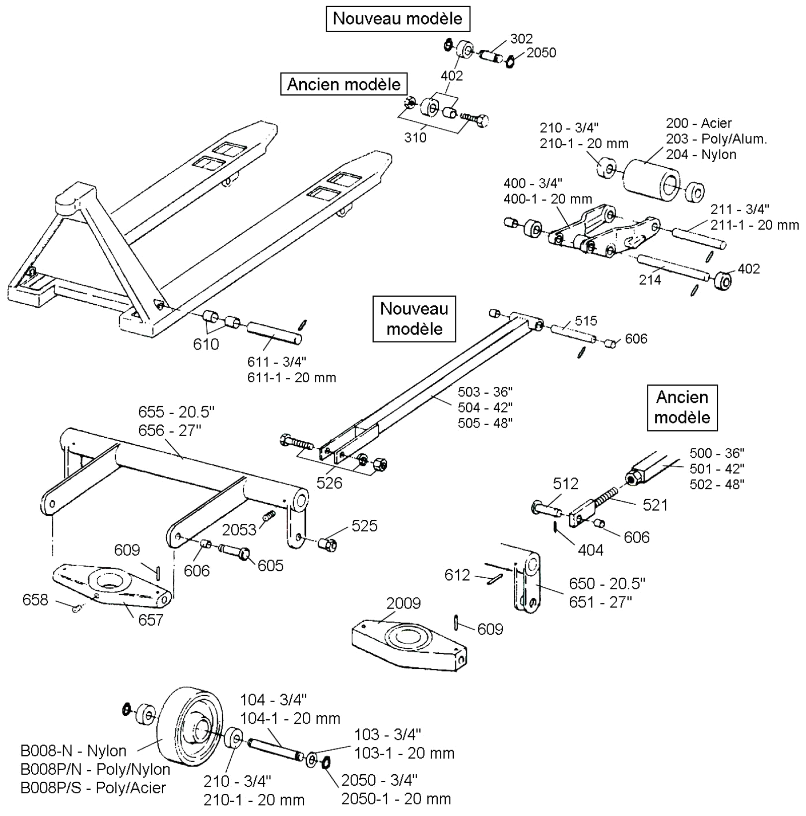

Mobile – ML50

Unité hydraulique
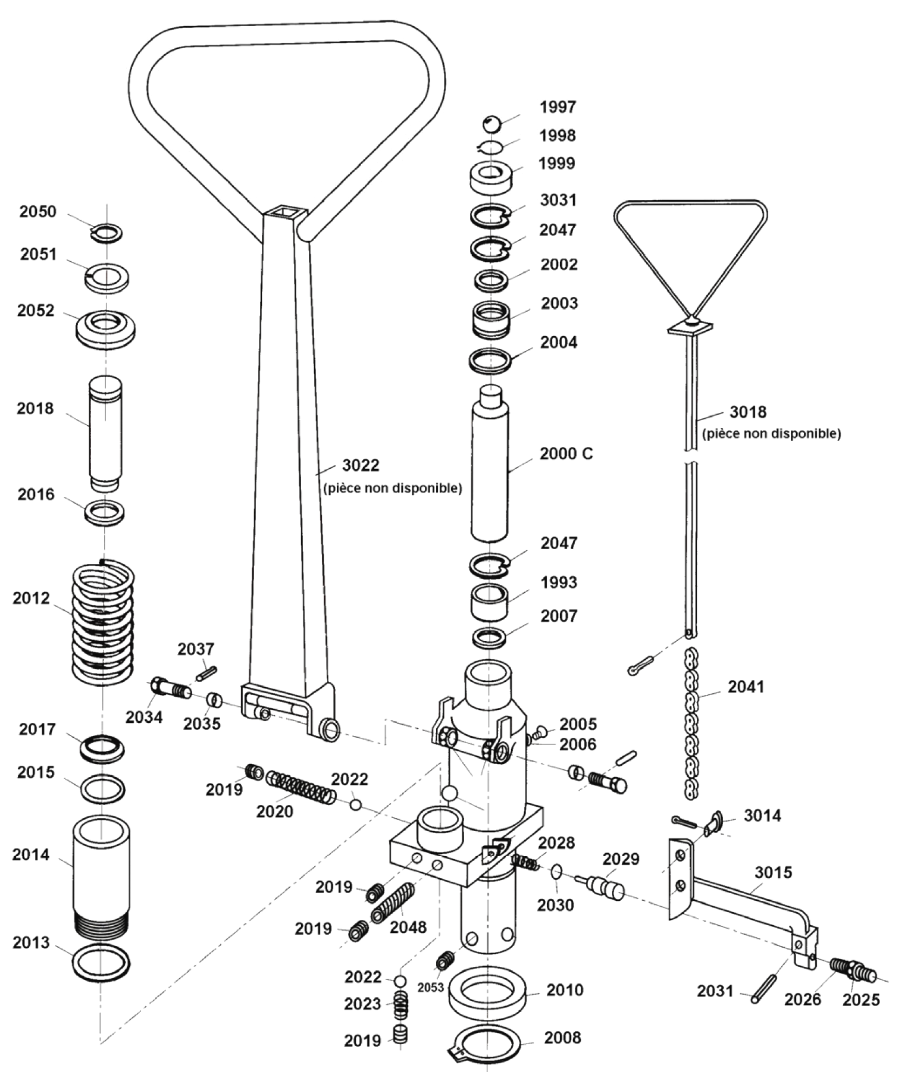

Mobile – ML55

Unité hydraulique
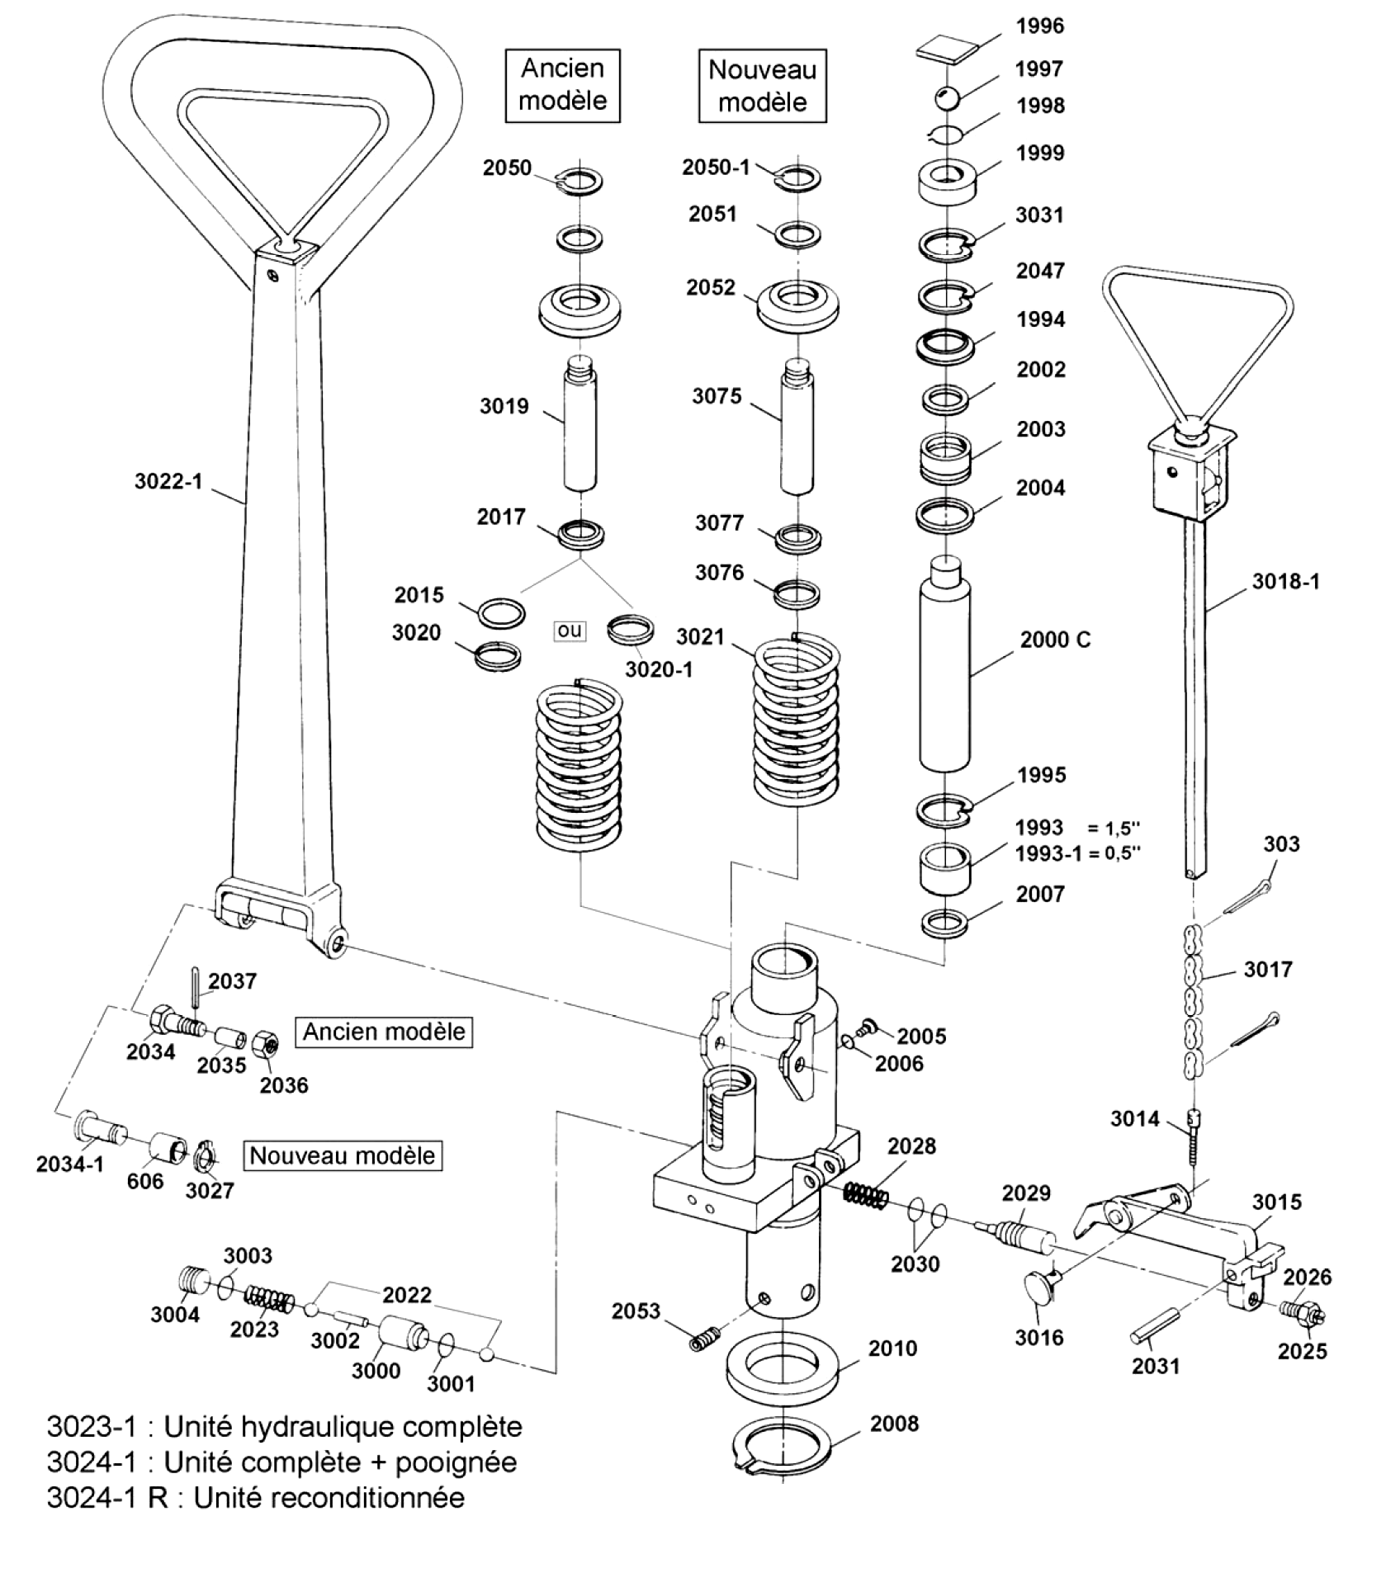

Mobile – BF II (Eco)

Châssis
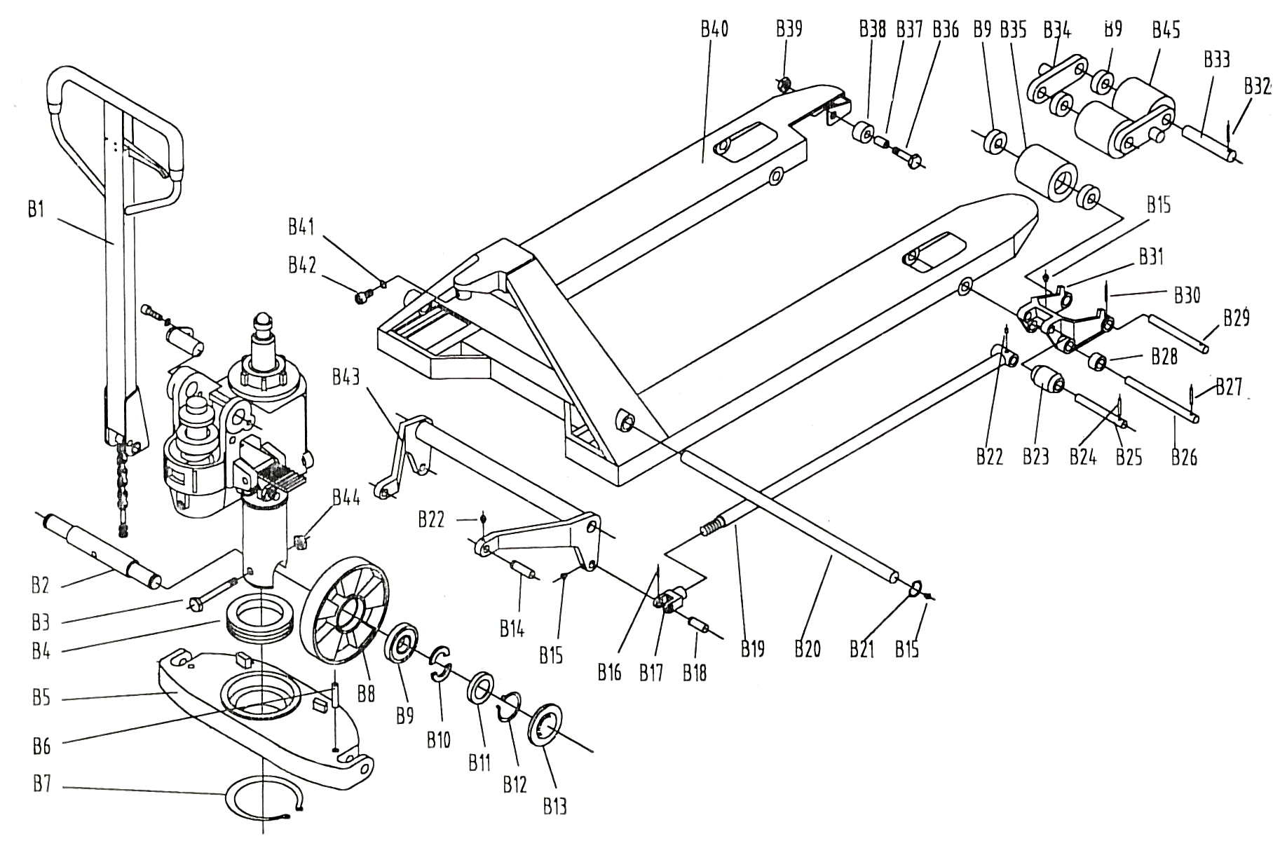

Mobile – BF II (Eco)

Unité hydraulique
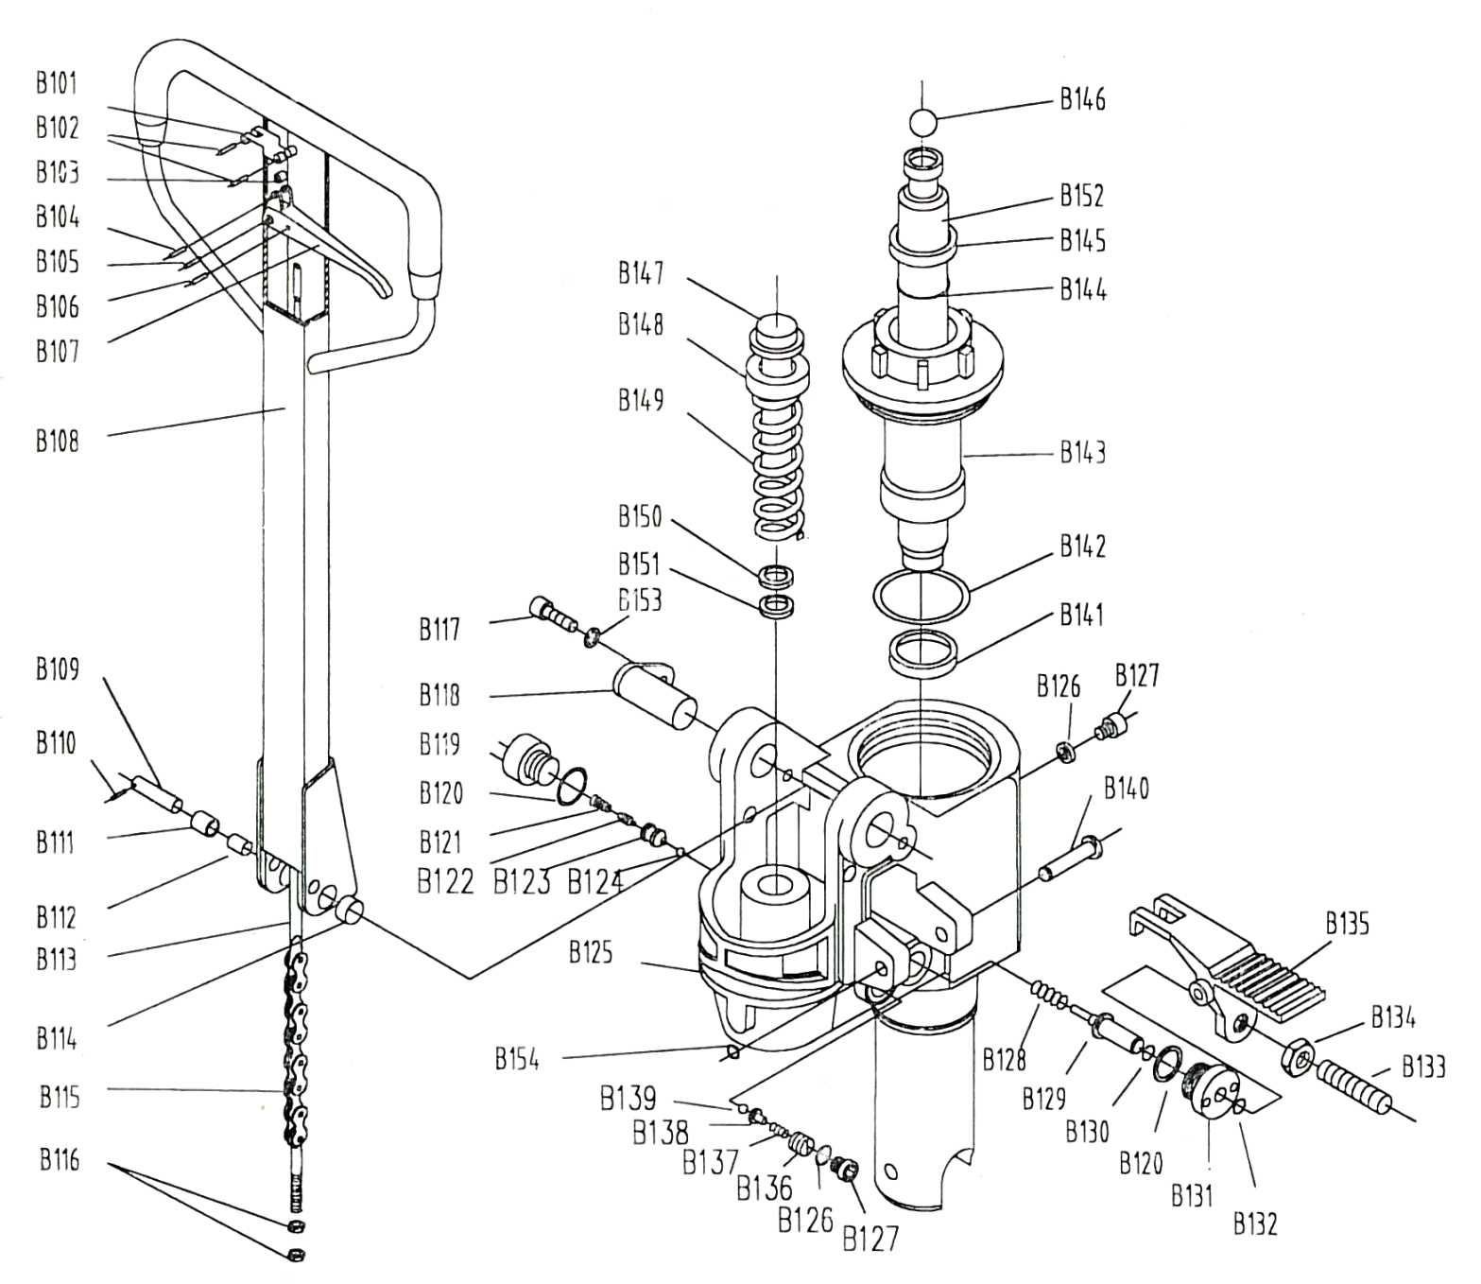

Toyota – HPT28U

Châssis

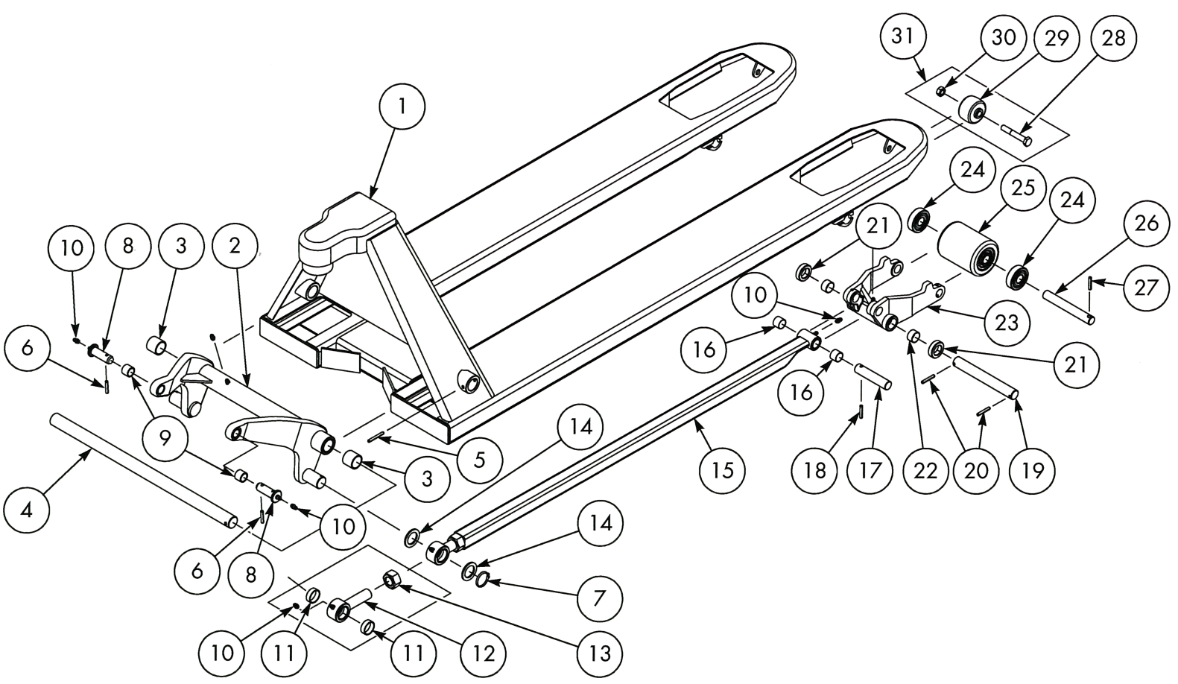

1 | Châssis |  | 12 | NB-10226 |  | 23 | NB-10212
2 | NB-10201 (larg. 20,5’’) |  | 13 | NB-10224AF |  | 24 | PL20214
 | NB-10202 (larg. 27’’) |  | 14 | NB-10224B |  | 25 | PL20210BN-B (nylon)
3 | NB-10203A |  | 15 | NB-10224x36 (long. 36’’) |  |  | 167609 (poly)
4 | NB-10204B (larg. 20,5’’) |  |  | NB-10224x42 (long. 42’’) |  |  | PL20210S-BRG (acier)
 | NB-10204A (larg. 27’’) |  |  | NB-10224x48 (long. 48’’) |  | 26 | NB-10215-I
5 | NB-10269A |  | 16 | NB-10206 |  | 27 | NB-10269D
6 | 20001 |  | 17 | NB-10225B |  | 28 | NB-10282
7 | NB-10226C |  | 18 | NB-10225BA |  | 29 | NB-10281
8 | 166701 |  | 19 | NB-10219 |  | 30 | NB-10283
9 | PL-30206 |  | 20 | NB-10269 |  | 31 | NB-10281C
10 | 27662 |  | 21 | NB-10212A
11 | NB-10226A |  | 22 | NB-10203

Toyota – HPT28U

Unité hydraulique et poignée
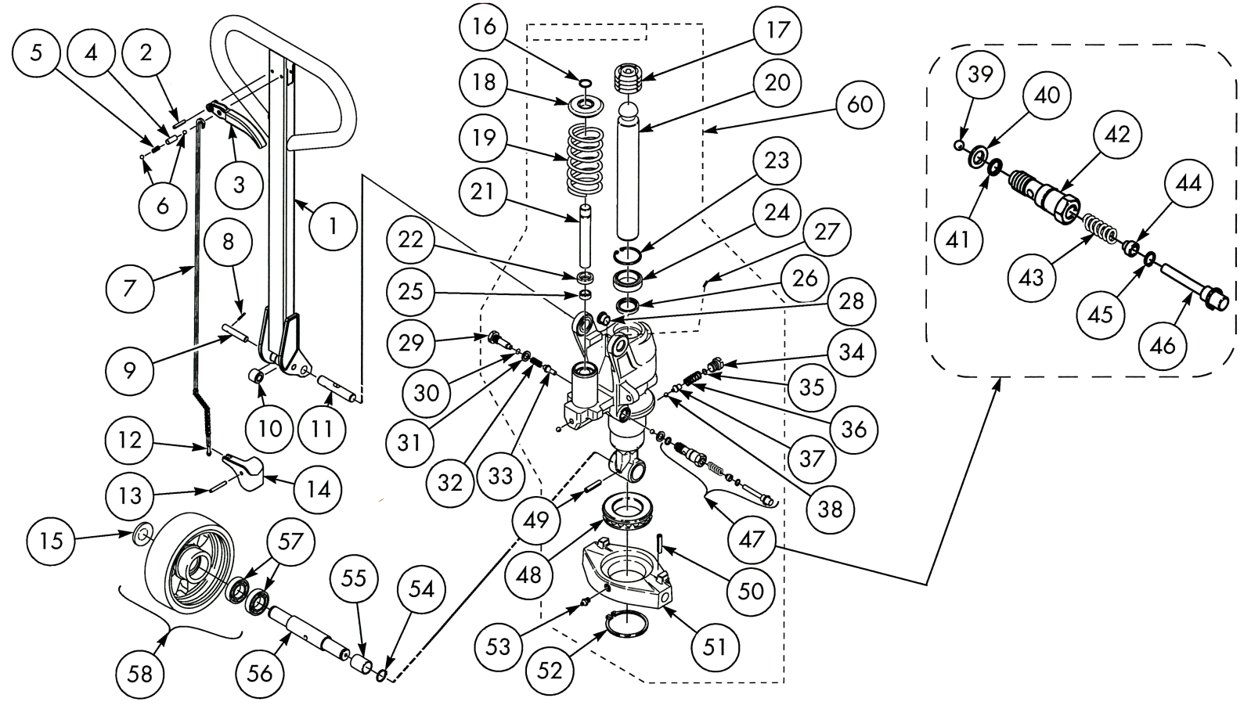
1 | PL-40276TDM |  | 22 | 7500105CE |  | 43 | 47071
2 | 20105 |  | 23 | 20642 |  | 44 | 49513
3 | PL-40274BDM |  | 24 | 20066 |  | 45 | 7500100
4 | 54140 |  | 25 | 215866 |  | 46 | 7500116
5 | 218182 |  | 26 | 215867 |  | 47 | 7518604CE
6 | 20065 |  | 27 | 20014 |  | 48 | 213056
7 | 215775 |  | 28 | 215913 |  | 49 | 220312
8 | 20461 |  | 29 | 221586 |  | 50 | 20001
9 | 47930 |  | 30 | 24213 |  | 51 | 215092
10 | 202755 |  | 31 | 235545 |  | 52 | 21737
11 | 7500086 |  | 32 | 39106 |  | 53 | 27662
12 | 21094 |  | 33 | 223935 |  | 54 | 20019
13 | 220312 |  | 34 | 221232 |  | 55 | 161637
14 | 215128 |  | 35 | 22032 |  | 56 | 220310
15 | 156623BT |  | 36 | 221227 |  | 57 | 22226
16 | 20043 |  | 37 | 2211231 |  | 58 | 251186 (nylon)
17 | 215803 |  | 38 | 22055 |  |  | 160422 (poly)
18 | 215282 |  | 39 | 20065 |  |  | 20096BT (poly/acier)
19 | 215156 |  | 40 | 212588 |  |  | 160433 (acier)
20 | 215030 |  | 41 | 22032 |  | 60 | 220069 (standard)
21 | 215286 |  | 42 | 7500112 |  |  | 215031 (surcharge)
 |  |  |  |  |  |  | 243772 (reconditionné)

Toyota – HPT-SS (inox)

Châssis

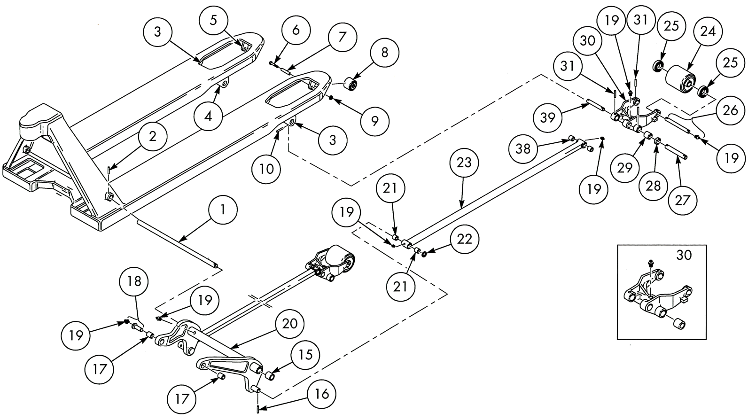

1 | 49882 (larg. 20,5’’) |  | 15 | 47167 |  | 24 | 167598
 | 51501 (larg. 27’’) |  | 16 | 179415 |  | 25 | 210061
2 | 179414 |  | 17 | 179335 |  | 26 | 51479
3 | 179326 |  | 18 | 179328 |  | 27 | 131676
4 | 179325 |  | 19 | 179334 |  | 28 | 159280
5 | 179667 |  | 20 | 179324 (larg. 20,5’’) |  | 29 | 51805
6 | 179670 |  |  | 179332 (larg. 27’’) |  | 30 | 179387
7 | 172862 |  | 21 | 30023 |  | 31 | 179415
8 | 47150 |  | 22 | 179327 |  | 38 | 47117
9 | 179671 |  | 23 | 179375-122 |  | 39 | 179329
10 | 179416

Toyota – HPT-SS (inox)

Unité hydraulique et poignée
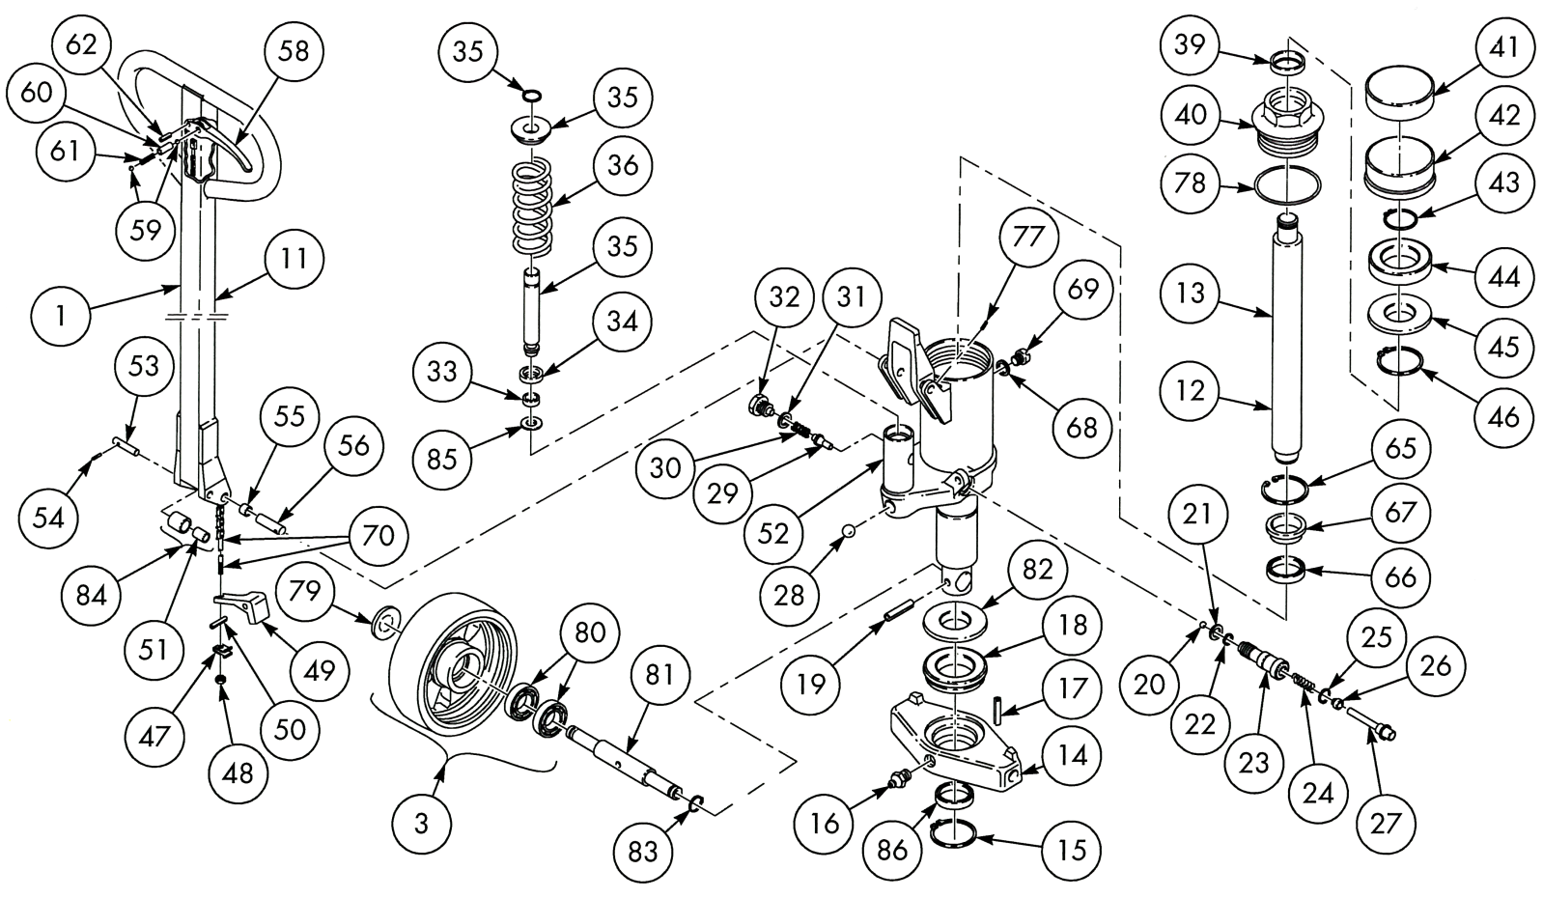
1 | 175769 |  | 30 | 39106 |  | 55 | 182769
2 | 129882 |  | 31 | 37218 |  | 56 | 49886
3 | 161804 (nylon) |  | 32 | 176223 |  | 58 | 173765
 | 161806 (poly) |  | 33 | 21065 |  | 59 | 218344
11 | 177115 |  | 34 | 7500105 |  | 60 | 165194
12 | 180852 |  | 35 | 209911 |  | 61 | 218345
13 | 179380 |  | 36 | 166241 |  | 62 | 28569
14 | 179346 |  | 39 | 20066 |  | 65 | 20101
15 | 28574 |  | 40 | 49918 |  | 66 | 22034
16 | 179334 |  | 41 | 47997 |  | 67 | 47039
17 | 179414 |  | 42 | 164675 |  | 68 | 153487
18 | 179345 |  | 43 | 179412 |  | 69 | 179381
19 | 166246 |  | 44 | 20908 |  | 70 | 129209
20 | 20065 |  | 45 | 47995 |  | 77 | 28572
21 | 47050 |  | 46 | 28571 |  | 78 | 21024
22 | 22032 |  | 47 | 165197 |  | 79 | 156623
23 | 179384 |  | 48 | 158452 |  | 80 | 210062
24 | 47071 |  | 49 | 165198 |  | 81 | 179347
25 | 22318 |  | 50 | 166246 |  | 82 | 179342
26 | 49513 |  | 51 | 182768 |  | 83 | 158809
27 | 179385 |  | 52 | 179379 |  | 84 | 165196
28 | 179383 |  | 53 | 129208 |  | 85 | 137020
29 | 47049 |  | 54 | 28578 |  | 86 | 209932

